“THE SPHINX”
The Great Sphinx of Giza is located in Egypt. The Sphinx was built approximately 2500 B.C.
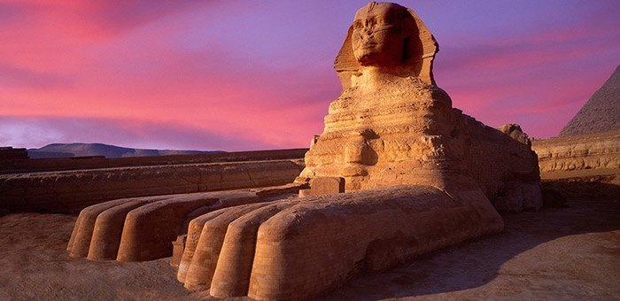
Is a statue that depicting a Sphinx. It is a mythological creature that has the body of lion and the head of a human with the wings of an eagle.
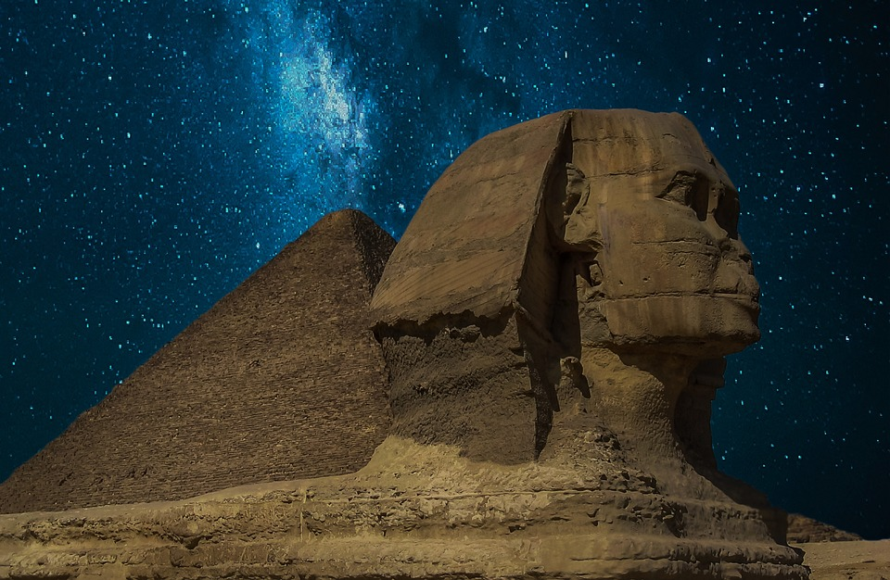
In addition, the creator is unknown but believed to have been designed, sculpted and constructed by Ancient Egyptians of the old kingdom. Also the Ancient Egyptian discovered the Sphinx.
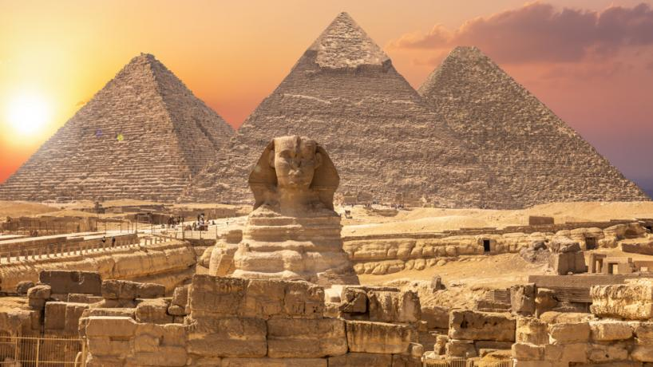
Moreover, the excavations for its discovery began in Northern Israel for the first time in 1950.
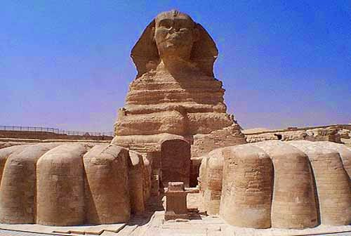
Also the monument was built because of their faith in the Sun God. Furthermore, it served as the quarry for the pyramids and other monuments in the area.
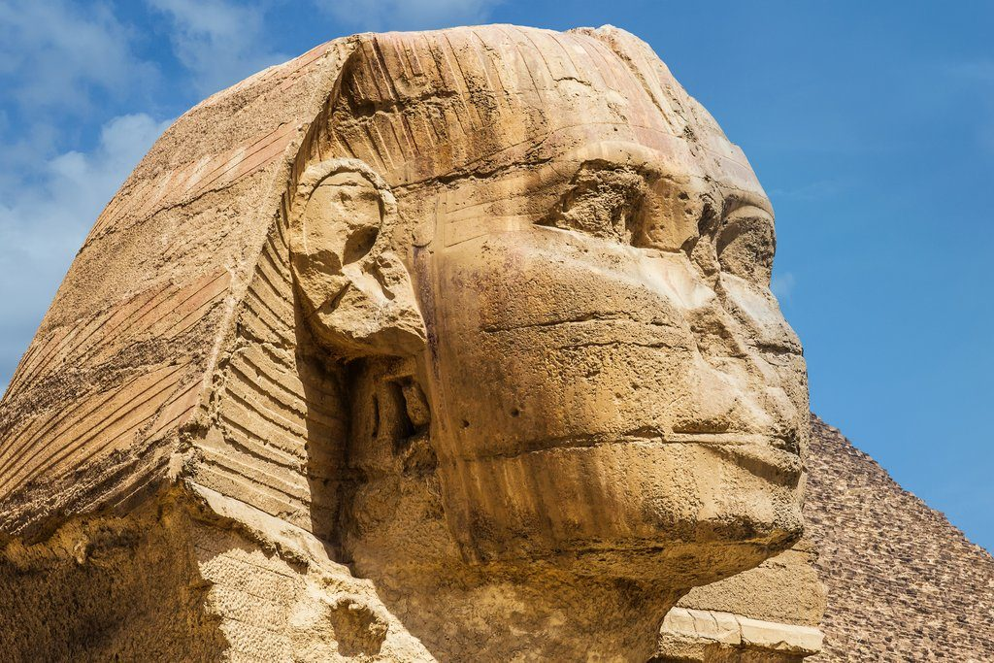

As well, the most important artifacts found were more than 10 Egyptian statues.
Moreover, in the surrounding complexes was found the Temple of the Sphinx and a Temple in the valley.
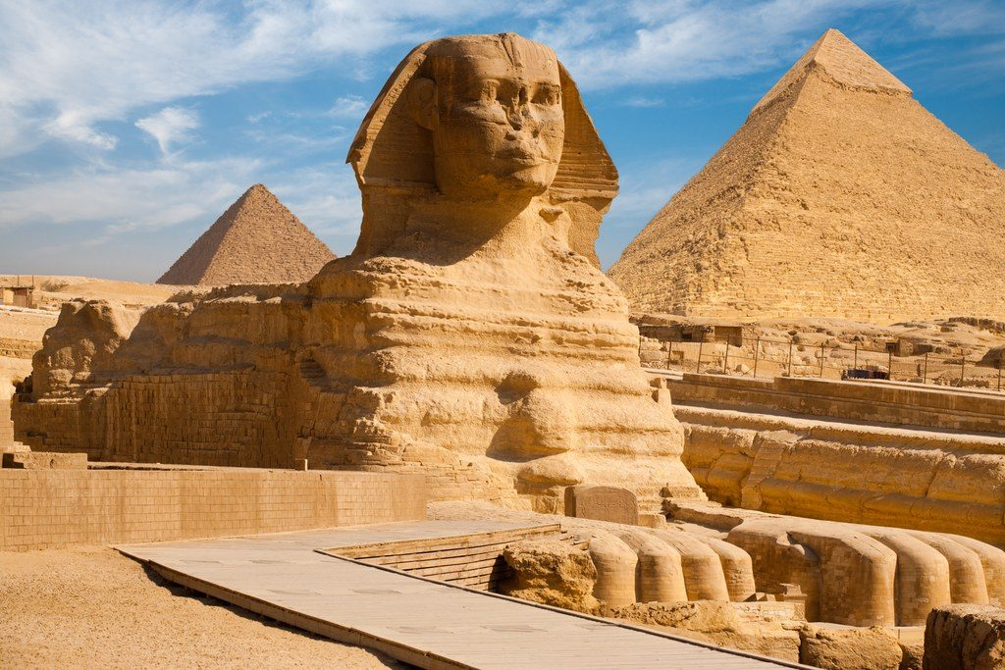
Finally, the material was used to built it, is limestone.
