Look at the pictures and with the help of the questions write down the story.
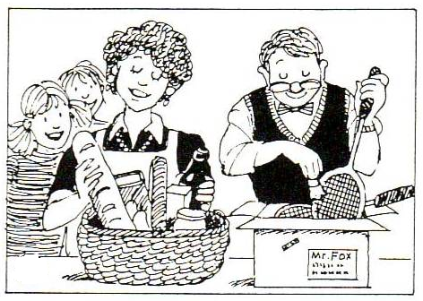 | 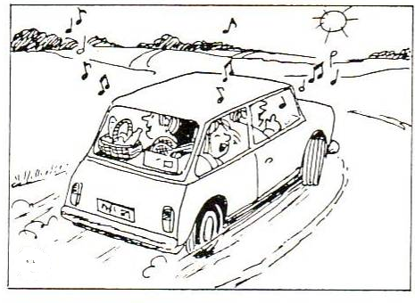
Who is in the picture?  What are they doing?  What do they put in the basket and in the box? | Where are they going?  How are they going?  What are they doing in the car?
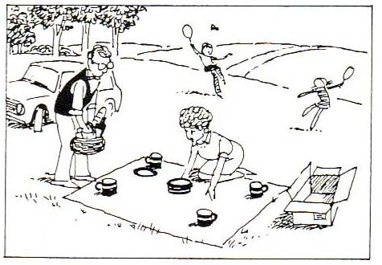 | 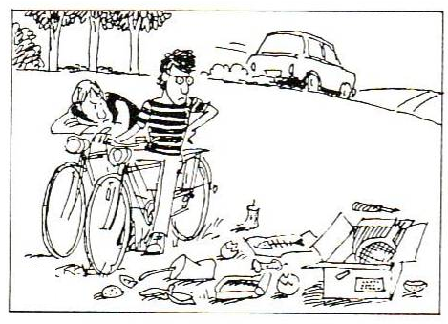
Where are they?  What are the parents doing?  What are the children doing? | Where are they going now?  Who arrives?  What do they find?
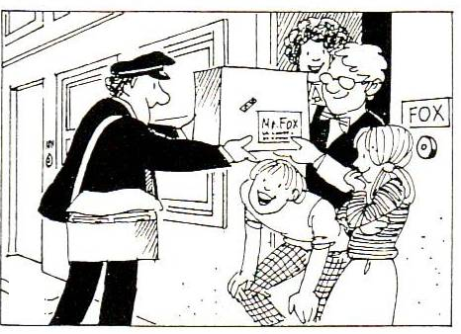 | 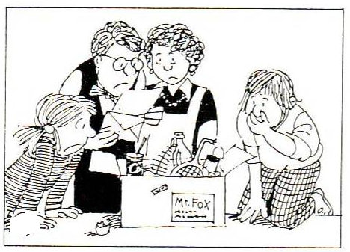
What's the family's name?  Who rings the bell the next day?  What does he bring?  How do the people react? | What's in the parcel?  How do the people react now?

On a nice Sunday morning.....

……………………………………………………………………………………………………………………………………………………………………………………………………………………………………………………………………………………………………………….
………………………………………………………………………………………………………………………………………………………………………………………………………………………………………………………………………………………………………………………………………………………………………………………………………………………………………………………………………………………………………………………………………………………………………………………………………………………………………………………………………………………………………………………………………………………………………………………………………………………………………………………………………………………………………………………………………………………………………………………………………………………………………………………………………………………………………………………………………………………………………………………………………………………………………………………………
………………………………………………………………………………………………………………………………………………………………………………………………………………………………………………………………………………………………………………………………………………………………………………………………………………………………………………………………………………………………………………………………………………………………………………………………………………………………………………………………………………………………………………………………………………………………………………………………………………………………………………………………………………………………………………………………………………………………………………………………………………………………………………………………………………………………………………………………………………………………………………………………………………………………………………………………………………………………………………………………………………………………………………………………………………………………………………………………………………………………………………………………………………………………………………………………………………………………………………………………………………………………………………………………………………………………………………………………………………………………………………………………………………………………………………………………………………………………………………………………………………………………………………………………………………………………………………………………………………………………………………………………………………………………………………………………………………………………………………………………………………………………………………………………………………………………………………………………………………………………………………………………………………………………………………………………………………………………………………………………………………………………………………………………………………………………………………………………………………………………………………

