Puss in Boots

**Read the story carefully and answer the following questions!** 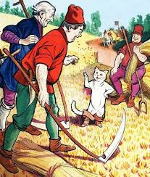

1. Who is Mr Miller?
2. How many children has he got?
3. What did he give his sons?
4. Did peter like his present?
5. What did the cat ask Peter to give it?
6. What did the cat do in the woods?
7. What was the first gift the cat took the king?
8. Who, did he say, the gift was from?
9. Where did the king go with his daughter in the carriage?
10. What did Puss in Boots tell Peter to do when he saw king and his daughter ?
11. Could Peter find his clothes when he came out of the river?
12. 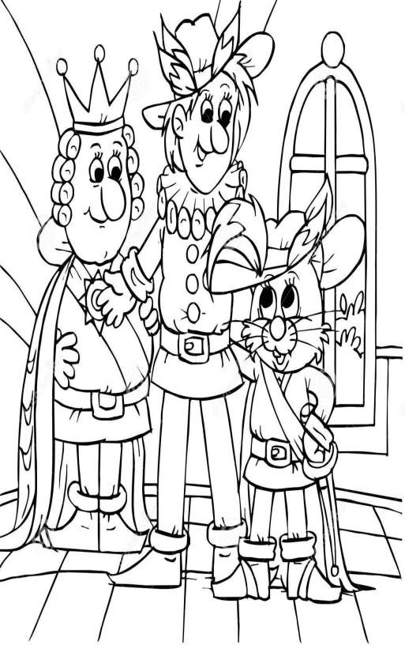Who gave him new clothes?
13. Did Peter like Princess Lilly?
14. Did Princess Lilly like Peter?
15. What did cat ask the farmers?
16. Who lives in the castle?
17. Why did the cat ask the wizard to be a mouse?
18. How did the king feel about his daughter in the end?
19. How did Puss in Boots feel about his master in the end?
20. What do you think happened in the end?

