Easter celebration in Greece
Every corner of Greece celebrates Easter with its own unique way. The week preceding Greek Easter is called the Holy Week and each day of that week relates directly to a particular event that took place during the last days of Christ prior to his crucifixion.
During the Holy Week, many people go to church every afternoon. Greeks fast and they don’t eat meat and dairy products. Some of them don’t use oil in their meals until midnight on Easter Saturday, after the symbolic Resurrection.
The preparations for the celebration of the Resurrection start on Holy Thursday. Communion services in church start early in the morning. On that day housewives traditionally prepare tsourekia (a kind of sweet bread) and colour their eggs with special red dyes. The eggs symbolise the renewal of life and the red colour symbolises the blood of Christ. Housewives place the first red egg on the icon stand of the house in order to cast out evil spirits. They also put a red cloth outside their windows or doors for everybody to see and that their red eggs are ready.

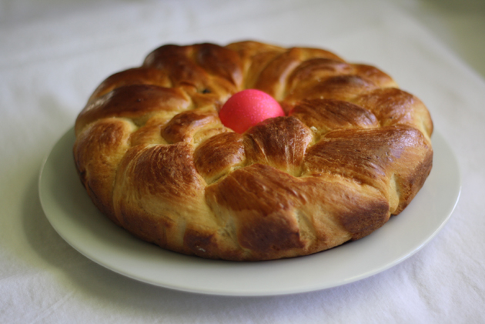

Evening church services include a symbolic representation of the crucifixion and the period of mourning begins. Everyone who believes, go to worship the cross and leave flowers they collect or buy which will decorate the Epitaph (Bier of Christ). After the church services young women and children decorate the Epitaph and in some parts of Greece, they stay in church throughout the night, in traditional mourning.
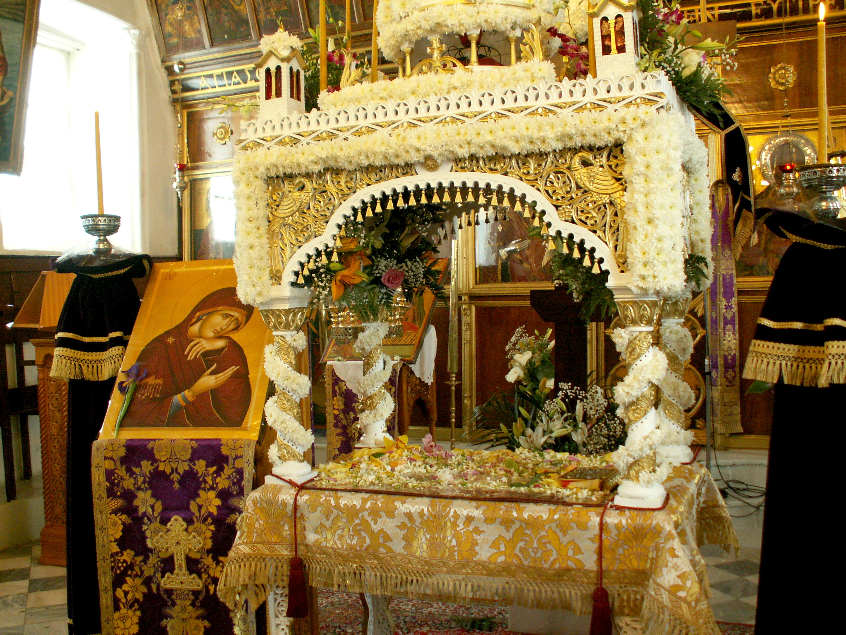

In the morning of Holy Friday, Christ's Burial is re-enacted in church and the church bells ring the death knell all morning. It’s the most sacred day of Holy Week. It’s a day of mourning and it’s a day of rest for men and women. Housewives do not do any house chores, avoiding even cooking. People go to three churches at least to worship their Epitaphs and young children pass on their knees beneath the epitaph vertically and horizontally, forming a cross. In the evening, the Epitaph is carried on the shoulders of the faithful in a procession through the community to the cemetery, and back. People with candles follow the Epitaph, who goes round the village or area. After the church service the faithful worship the epitaph and get a few of its flowers for blessing.

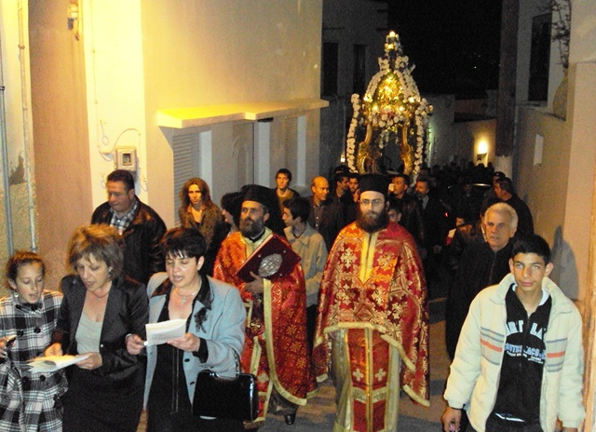

On Easter Saturday morning, preparations start for the festive dinner of the night of the Resurrection and housewives cook "maghiritsa" (a tripe and herbs soup). Shortly before midnight, people gather in church holding their Easter decorated candles which they light with the "Holy Light". The priest will take the flame and light the candles of those closest to him with the eternal flame. These people will then pass the flame on to others and so on, until it has reached all the people gathered outside, and everyone's candle is alight. When the priest says "Christ is risen" (Christos Anesti), people exchange wishes, they kiss each other "Kiss of Love" and they crack red eggs. Fireworks are then let off in celebration.

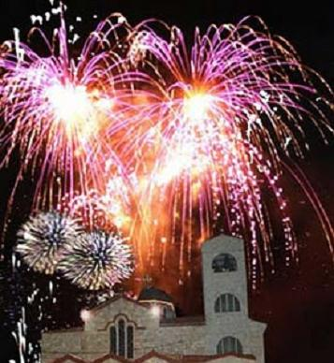

The people take their lit candles home protecting their flames so that they don't go out for at least forty days for good luck. Back home dinner follows. They crack red eggs, they eat maghiritsa and other traditional dishes and they drink red wine.
On Easter Sunday morning, in many parts of the country lamb is prepared on the spit. In other regions, the meat for the Easter table - lamb or kid - is roasted in the oven. There is a festive atmosphere everywhere and people eat, drink and dance usually until late into the night.

