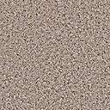

Όνομα: …………………..

- Τι να ‘χει άραγε ο παππούς;
…………………………………………………………………………………………………………………………………………………………………………………………………………………………………………………………………………………………………………………………………………………………………………………………………………………………………………………………………………………………………………………………………………………………………………………………………………………………………………………………………………………………………………………………………………………………………………………………………………………………………………………………………………………

