Χρωματίζω το σωστό

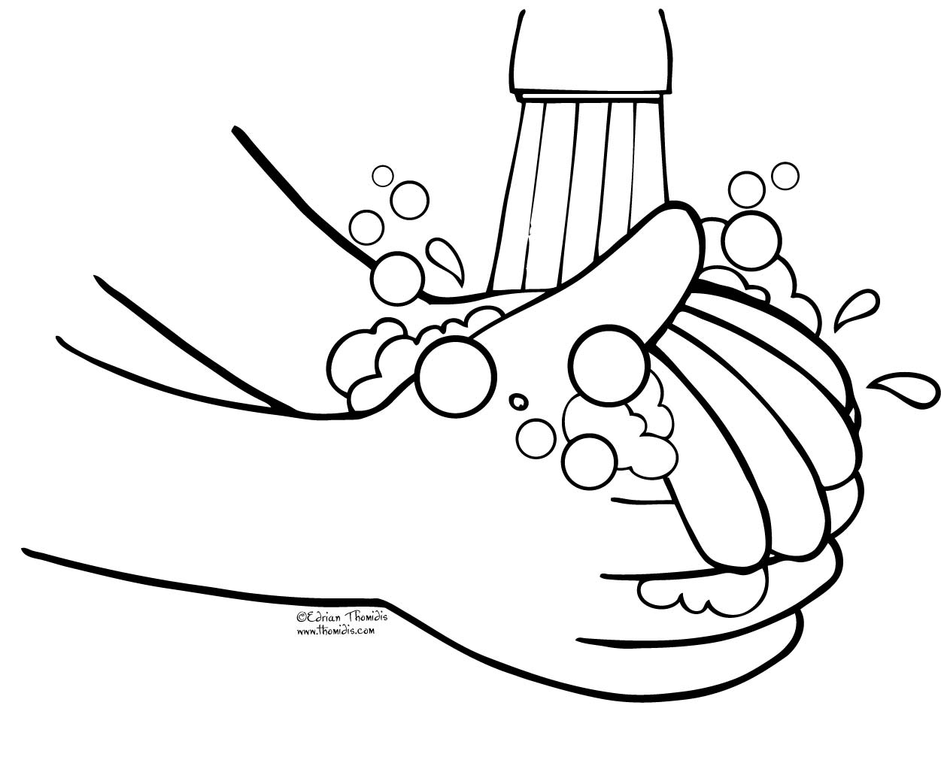Πλένω τα χέρια μου με …….

|  |  |  |
| --- | --- | --- |
| http://cliparts.co/cliparts/6ip/58R/6ip58RnXT.png | http://kidsfront.com/coloring-pages/lg_bw/comb.gif | http://images.clipartof.com/thumbnails/1167141-Cartoon-Of-An-Outlined-Liquid-Soap-Dispenser-Royalty-Free-Vector-Clipart.jpg |



Βουρτσίζω τα δόντια μου με……

|  |  |  |
| --- | --- | --- |
| http://3.bp.blogspot.com/-79DNg663PDk/U5zc-7j4v3I/AAAAAAAAEVY/Pcj8_O0nWV4/s1600/scissors.png | http://cliparts.co/cliparts/6ip/58R/6ip58RnXT.png | http://thumbs.dreamstime.com/x/soap-bubbles-illustration-22293098.jpg |

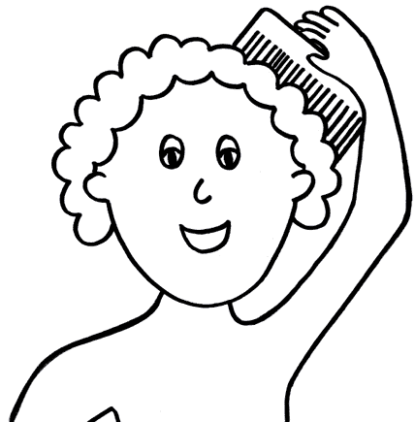

Χτενίζω τα μαλλιά μου με…..

|  |  |  |
| --- | --- | --- |
| https://encrypted-tbn3.gstatic.com/images?q=tbn:ANd9GcRcMnBHlwEDZfO8aA_LOMN4yrPeEBD96-azzpT_jr89-Go0mGazZQU_YShf | http://kidsfront.com/coloring-pages/lg_bw/comb.gif | http://cliparts101.com/files/737/89DA71E8D457F213241063181EBD7AB5/Cotton_Swab.png |

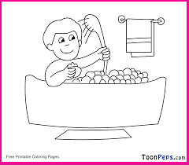Πλένω το σώμα μου με…….

|  |  |  |
| --- | --- | --- |
| http://kidsfront.com/coloring-pages/lg_bw/comb.gif | http://thumbs.dreamstime.com/z/old-sponge-isolated-white-34719119.jpg | http://thumb7.shutterstock.com/thumb_small/169/169,1254470974,1/stock-photo-nail-cutter-38124178.jpg |