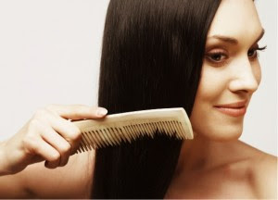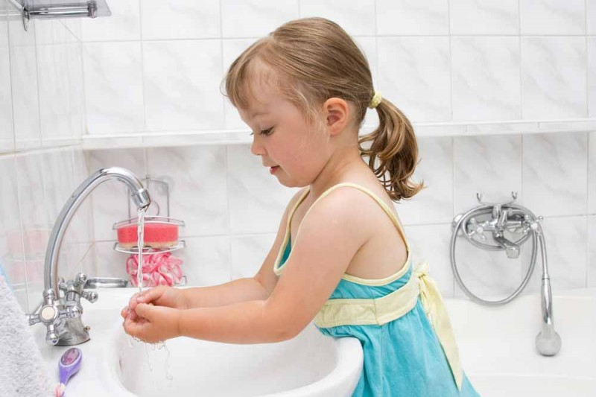

|  |  |  |
| --- | --- | --- |
| http://images.idiva.com/media/healthmeup/content/2014/Sep/soap.jpg | http://cf.ltkcdn.net/crafts/images/std/149334-319x425-glycerin-soap.jpg | http://thumbs.dreamstime.com/z/colorful-hairbrush-isolated-white-background-31032973.jpg |
| http://i.ebayimg.com/00/s/NTg3WDgxNw==/z/Q2EAAOxyNSVSQU5X/$(KGrHqJHJE8FIpnz2MbfBSQU5(Ds-g~~60_12.JPG?set_id=880000500F | http://www.nutritionrx.ca/wp-content/uploads/2015/04/Toothbrust-Test.jpg | http://alertmedical.org/wp-content/uploads/2014/09/Dangerous_Toothpaste_Ingredients.jpg |