THE MAGIC FLOWER
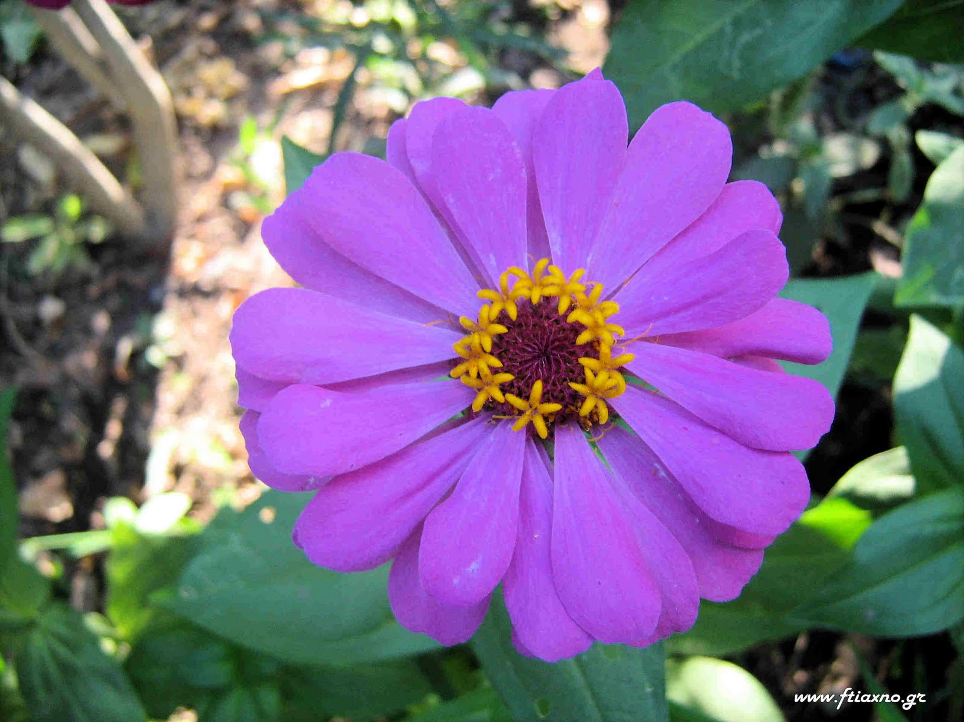


One day a couple went for a walk to the forest. The boy’s name was Stavros. The girl’s name was Helen.
They found a beautiful flower. Stavros cut it and gave it to his girl. Helen was excited and put it in her hair, but she didn’t know that it was a magic flower.
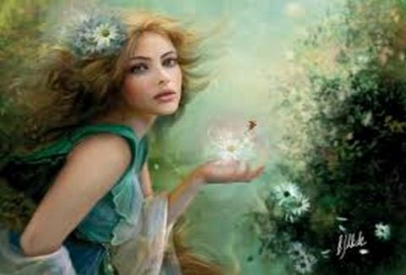
The next day, her hair had a strange color. Helen threw the flower away. The flower disappeared. From that day on, people couldn’t talk and express themselves. Helen realized that she shouldn’t have thrown the flower away.

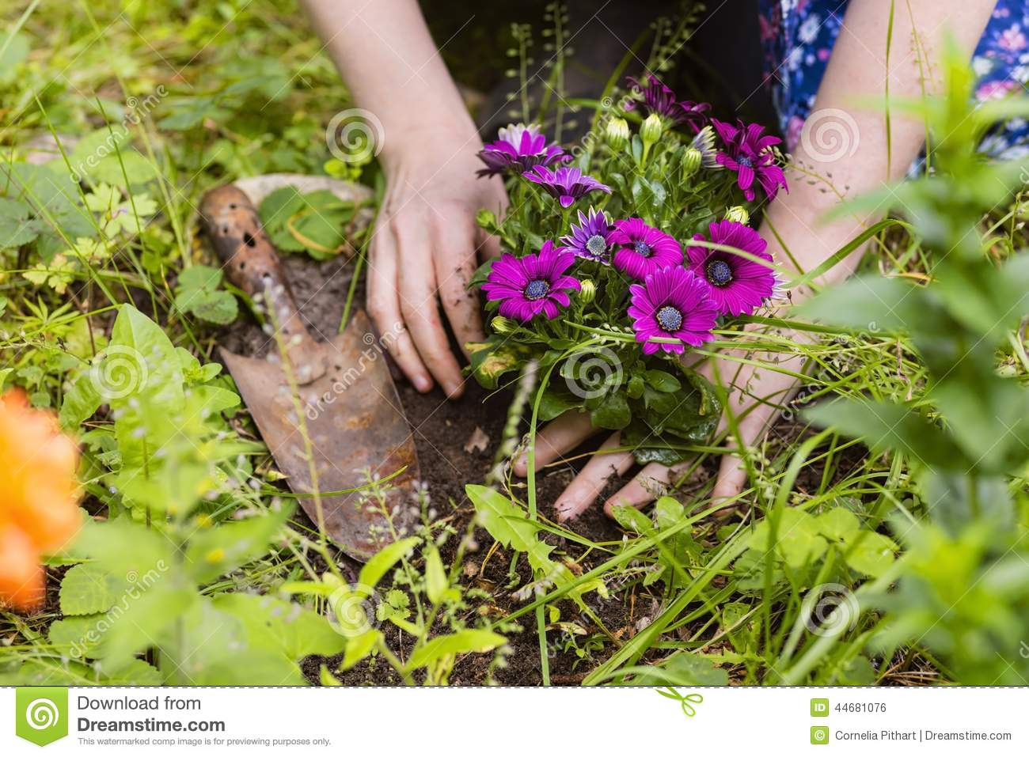
So, she decided to go to the forest alone and plant one single hair of her hair. She was so happy when she saw a magic flower growing through the ground. Since then Helen with Stavros go to their forest every day and take care of the magic flower.
THE END

