**OTE Tower**

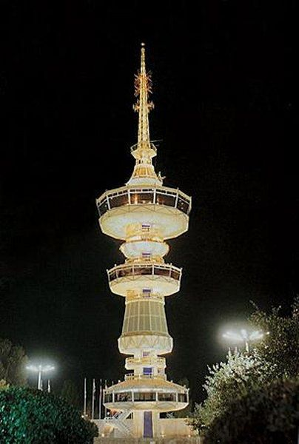 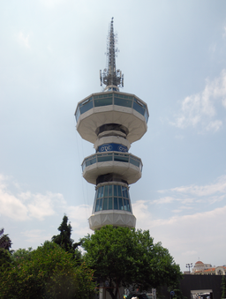

OTE Tower is a 76-metre- tall tower, located in the Thessaloniki International Exhibition Centre in central Thessaloniki, Greece. The tower opened in 1966 and was renovated in 2005. It is a modern monument of the city.

The tower was designed by the Greek architect A. Anastasiadis and was completed in 1965, with the first black and white broadcasts on a Greek television network taking place from the tower in 1966.The tower was also used in the 1970s to support the antennas of an experimental VHF analogue mobile telephone network. Today, it is used by the Cosmote cellular mobile telephone network.

The tower also opens up for events and exhibitions during the Thessaloniki International Trade Fair and a revolving restaurant operates all year round on the top floor. From there, you can enjoy the fabulous revolving view of the city while enjoying a delicious meal.

By

Fani Gogou