Magic Park

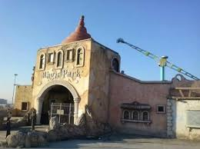

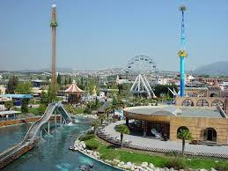

Magic Park

Thessaloniki’s wonderful Luna Park, which is called Magic Park, is perfect. It has got 37 rides and the best of all is the “Montagna”.

The “Montagna” goes very fast and it has got a steep descent with a height of 14 metres. The colour of the railway carriage is red and yellow and in each wagon four people are seated.

It is my favourite place in Thessaloniki.

By Anna Vlassi