THE ZOO

The Thessaloniki zoo is in Kedrinos hill. The visitor can see the fauna and flora of Greece. All the buildings are made of wood and stone for environmental purposes. We try to make the habitat to the animals like the real habitat. The visitors can see a lot of mammals like the bear, the wolf, the sheep, the rabbits and other mammals. Also birds like the green head duck, the parrot, the goose and other birds. Admission is free. I hope you like the zoo of Thessaloniki.

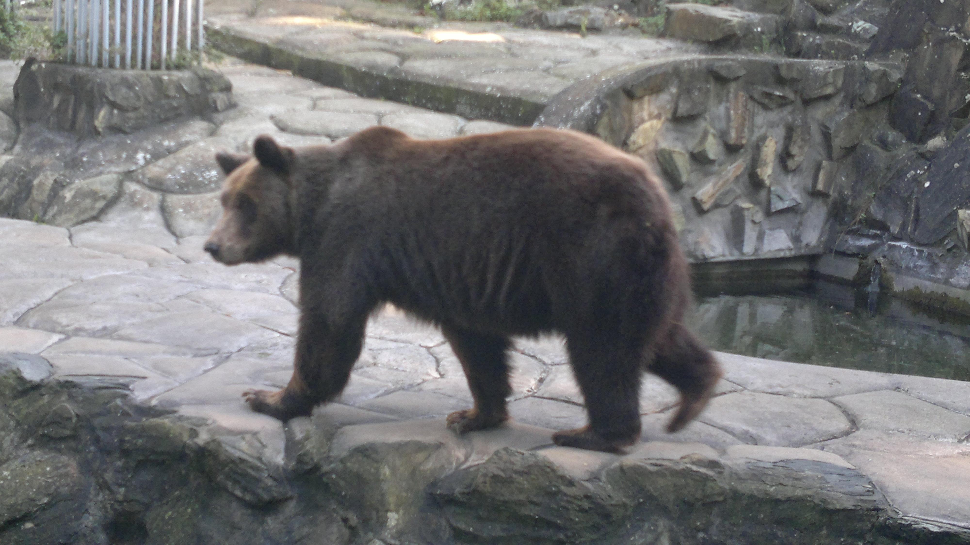

Thalis Tsionas

