*THE WAR MUSEUM*

The building of the War Museum was built in the beginning of the 20th Century by Vitaliano Posseli, but it opened its doors to the public in 2000.

Outside of the museum there are tanks and war airplanes. Inside the museum there are 3 levels.

The underground level is dedicated to the singer Sofia Vembo. Sofia Vembo was born in 1910 and died in 1978. She had the nickname “Singer of the victory” because she sang and encouraged soldiers to fight.

On the groundfloor there are weapons from the 1821’s Revolution, t 1st and the 2nd World War and the Balkan War, in which Greece participated.

Finally, on the first level there are also weapons and photos from very important facts of the past.

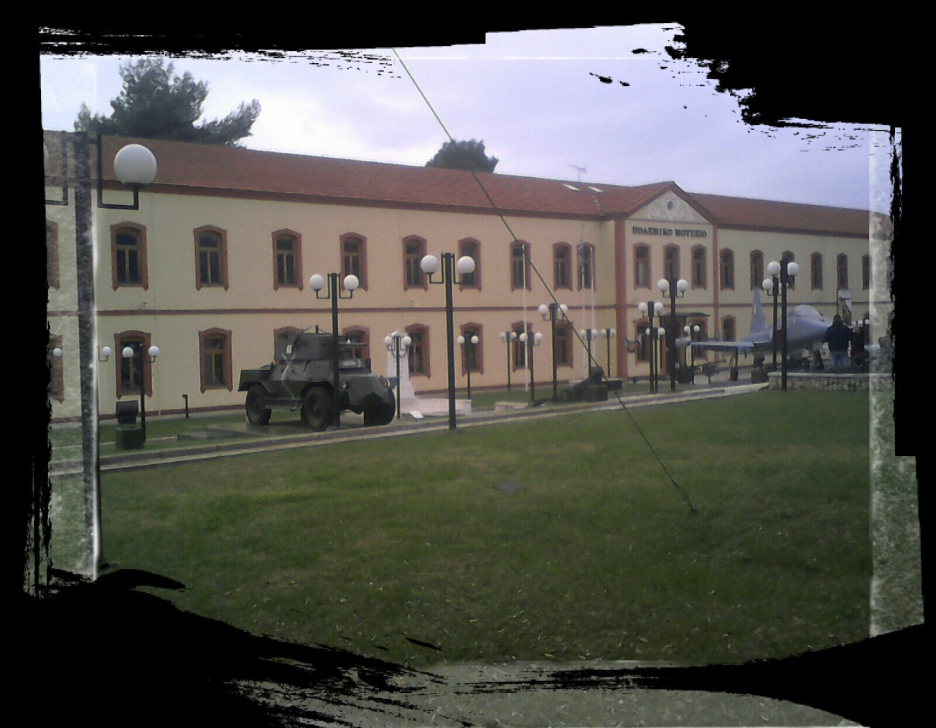

This is the War Museum of Thessaloniki!

By Malamas Bogatinis