**Ψηφιακό Λεξικό**

**ΟΙ 9 ΠΛΑΝΗΤΕΣ ΤΟΥ ΗΛΙΑΚΟΥ ΣΥΣΤΗΜΑΤΟΣ**

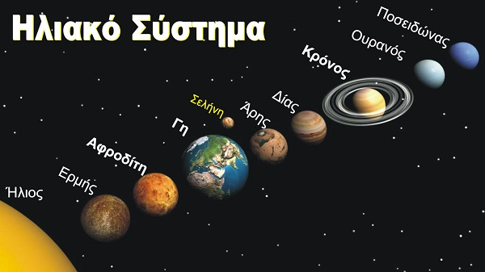

**Α**

|  |  |  |  |
| --- | --- | --- | --- |
|  | |  | | --- | | ΑΡΗΣ |  |  | | --- | |  | |

|  |  |  |  |
| --- | --- | --- | --- |
|  | |  | | --- | | ΑΦΡΟΔΙΤΗ |  |  | | --- | |  | |

**Γ**

|  |  |  |  |
| --- | --- | --- | --- |
|  | |  | | --- | | ΓΗ |  |  | | --- | |  | |

**Δ**

|  |  |  |  |
| --- | --- | --- | --- |
|  | |  | | --- | | ΔΙΑΣ |  |  | | --- | |  | |

**Ε**

|  |  |  |  |
| --- | --- | --- | --- |
|  | |  | | --- | | ΕΡΜΗΣ |  |  | | --- | |  | |

**Κ**

|  |  |  |  |
| --- | --- | --- | --- |
|  | |  | | --- | | ΚΡΟΝΟΣ |  |  | | --- | |  | |

**ΟΥ**

|  |  |  |  |
| --- | --- | --- | --- |
|  | |  | | --- | | ΟΥΡΑΝΟΣ |  |  | | --- | |  | |

**Π**

|  |  |  |  |
| --- | --- | --- | --- |
|  | |  | | --- | | ΠΛΟΥΤΩΝΑΣ |  |  | | --- | |  | |

|  |  |  |  |
| --- | --- | --- | --- |
|  | |  | | --- | | ΠΟΣΕΙΔΩΝΑΣ |  |  | | --- | |  | |

## Σ

|  |  |  |  |
| --- | --- | --- | --- |
|  | |  | | --- | | ΣΕΛΗΝΗ |  |  | | --- | |  | |

Η Σελήνη, αν και δεν είναι πλανήτης,

είναι ο μοναδικός φυσικός δορυφόρος της Γης.