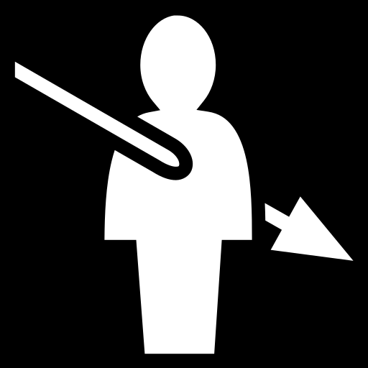

Vocabulary

body idioms
Arm
cost an arm and a leg  up in arms | very expensive  see red have a cow very angry
Blood
make my blood boil  make my blood run cold  my flesh and blood  blood is thicker than water  in cold blood | make me really angry  shocks me /scares me  relative  «το αίμα νερό δε γίνεται»  «εν ψυχρώ»
bones
bag of bones  show/ throw someone at bone  work your fingers to the bone | Bony /all skins and bones/ extremely thin  say something good as a small reward  be hard working
brain
brain like a sieve  all brains  have something in my brain | bad memory (opp. like an elephant)  brainy  be obsessed with an idea have a be in my bonnet
Back
get off my back!  have my back to the wall  stab somebody in the back  back me up! | Stop criticizing  be in serious difficulty  betray  Support me
chin
Chins up | don't get disappointed ; be strong; think positive; every cloud has a silver lining

Eye
catch somebody’s eye  see eye to eye with somebody  turn a blind eye to sth  the apple of my eye  in the eye of the storm  Eagle’s/ Hawk’s eyes /vision  eye in the back of my head  eyes wide open  look somebody in the eyes  raise eyebrows | find somebody attractive  share the same perspective  ignore intentionally  my favorite  deeply involved ; in trouble  good vision good perspective  very observant  be fully aware of  tell the truth  show surprise
Ear
all ears  fall on deaf ears  grin smile from ear to ear  Lend an ear to somebody  music to my ears  turn a deaf ear to something  play it by ear | eager to listen  be ignored  extremely happy  listen carefully and sympathetically  listen something pleasant  refuse to listen  improvise; without preparation
face
face like thunder  face the music  keep a straight face  put on a brave face  two-faced/ double-faced  come face-to-face with somebody | very angry ; see red ; have a cow  accept the consequences  be serious  pretend the situation is not as serious as it looks  a snake in the grass; insincere and trustworthy  Confront

Feet
get cold feet  keep my feet on the ground  pull the rug under somebody's feet  put your feet up  Stand on your own 2 feet  two left feet  put my foot down  foot the bill | begin to hesitate  be practical ;sensible  unexpectedly remove all help  let your hair down; relax  be independent  Butterfingers ; all thumps and fingers  exert authority  pay the bill

finger
all thumps and fingers  keep your fingers crossed  a finger in every pie  work your fingers to the bone | clumsy ; Butterfingers  hope ;prey  get involved in many activities  be hard-working
hand
Hand in glove  hand-in-hand  get out of hand  iron fist/ hand in velvet gloves  like the back of my hand  live hand to mouth  the upper hand  get your hands dirty  have my hands full  in safe hands /in good hands  take the law into your own hands  be caught red-handed  hand on heart | work closely  be associated  get out of control  seemed gentle but is very hard  extremely well  don't have enough money to save just for nutrition needs  be in control  become involved  Be busy  be looked after  act instead of the police of justice  in act  promise sincerely
Hair
let your hair down  get in somebody's hair  split hairs | Relax; pull your feet up  annoy somebody  paid too much attention to differences that are unimportant
head
can't make head or tail  come to a head  hit the nail on the head  have your head in the clouds  head over heels in love  keep your head above the water  off the top of my head  a swollen head | Can’t understand it at all  Reaches a point where action should be taken  be absolutely right about something guessed  don't pay attention to what’s going on  passionately in love  trying to survive  instant ; not careful reaction  proud conceited as proud as a peacock
Heart
Heart of Stone  Heart of gold/ all hearts  change of heart  having my heart in the right place  have my heart in the mouth  learn something off by heart  break somebody's heart  hand on heart | cool hearted ; unfeeling  very sensitive  change of attitude or feeling  have good intentions  feel extremely anxious  Memorize  upset greatly  promise sincerely
mouth
have my heart in the mouth  live hand to mouth  learned from the horse’s mouth  make your mouth water | feel extremely anxious  don't have enough money to save just for nutrition  directly from the source  looks or smells extremely good
nose
nosy Parker  keep your nose clean  turn up your nose at something  stick your nose into somebody's business | Gossip  behave yourself  reject bc you think you're too good for it  get involved

skin
skin someone alive  all skin and bones  jump out of my skin | Punish someone severely  very thin ; skinny  shocked ; surprised

shoulder
a chip on the shoulder  give someone the cold shoulder  shrug shoulders | be resentful because of unfair treatment  deliberately ignore somebody  show lack of knowledge
Stomach
have some butterflies in my stomach  cast iron stomach | be in love / head over heels in love  can eat almost everything/ eat like a horse / eat like a pig
Tongue
tongue-tied  on the tip of my tongue  bite your tongue | have a frog in my throat; difficulty in expressing myself because of nervousness  you know something but can't express it  don't say what you are thinking

