https://gr.pinterest.com/pin/727261039805614952/
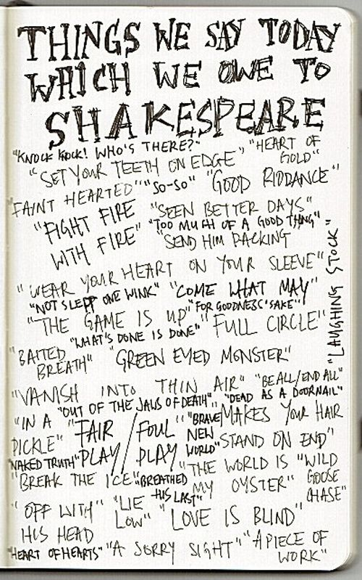
https://gr.pinterest.com/pin/249879479296704024/

https://www.flickr.com/photos/iqmatrix/3249052312/in/photostream/
William Shakespeare
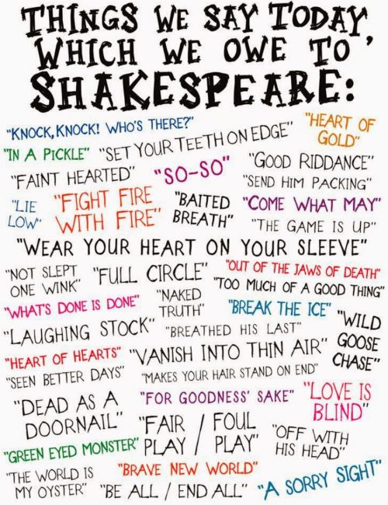

https://gr.pinterest.com/pin/278097345718049861/
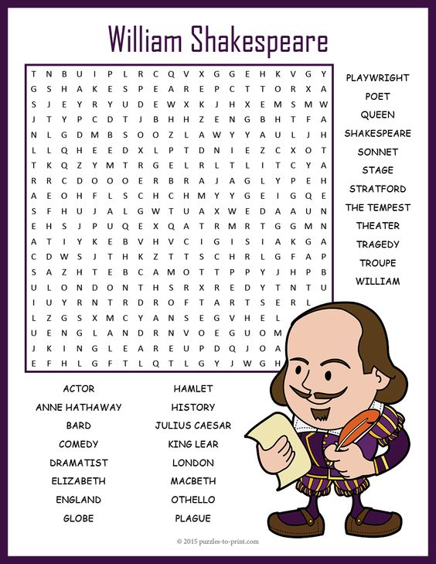
https://gr.pinterest.com/pin/235172411768888612/

