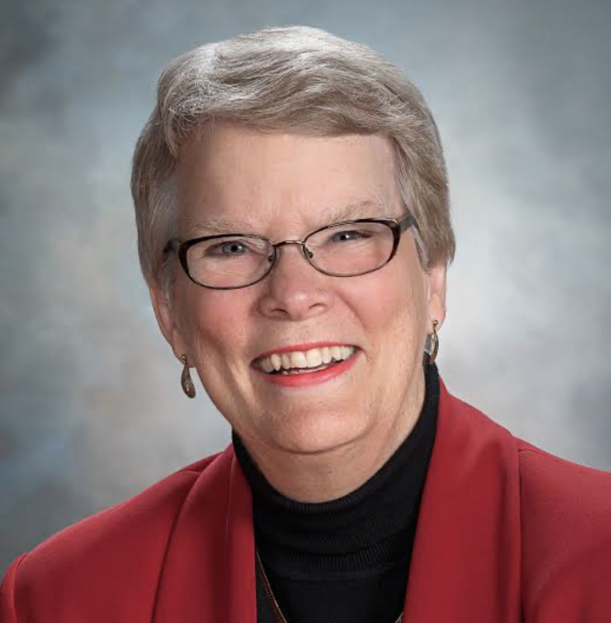
Carol Ann Tomlinson is William Clay Parrish, Jr. Professor and Chair of Educational Leadership, Foundations, and Policy at the University of Virginia’s Curry School of Education.

Prior to joining the faculty at UVa, she was a public school teacher for 21 years. During that time, she taught students in high school, preschool, and middle school and also administered programs for struggling and advanced learners. She was Virginia’s Teacher of the Year in 1974. At UVa, she was named Outstanding Professor in the education school in 2004 and received an All-University Teaching Award in 2008.

In 2022, Carol was ranked #16 in the Education Week Edu-Scholar Public Presence Rankings among the “200 University-based academics who are contributing most substantially to public debates about schools and schooling,” and as the #3 voice in Curriculum & Instruction.

She is author of over 300 books, book chapters, articles, and other educational materials including: How to Differentiate Instruction in Academically Diverse Classrooms 3rd Ed.), The Differentiated Classroom: Responding to the Needs of All Learners (2nd Edition), (with David Sousa) Differentiation and the Brain: How Neuroscience Supports the Learner-Friendly Classroom (2nd Ed.), So Each May Soar: The Principles & Practices of Learner-Centered Classroom., & Everybody’s Classroom: Differentiating for the Shared and Unique Needs of Diverse Learners. Her books on differentiation are available in 15 languages.

Carol works throughout the United States and internationally with educators who seek to create classrooms that are more effective with academically diverse student populations.

