**Friendship**

* Work in pairs to fill in the chart. Name ways in which you are the same or different with your classmate:

|  |  |
| --- | --- |
| The same or different? | |
| Same | **Different** |
|  |  |
|  |  |
|  |  |
|  |  |
|  |  |
|  |  |

* Fill in the mind map about friends. Use verbs:

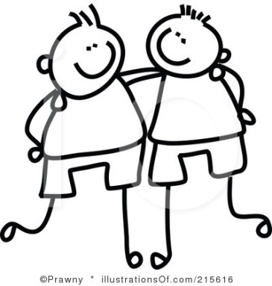

* Find definitions of a friend in pairs or in groups and fill in the chart:

|  |  |  |
| --- | --- | --- |
| A friend is someone who… | | |
|  |  |  |
|  |  |  |
|  |  |  |
|  |  |  |
|  |  |  |

* Who is **not** a friend?

|  |  |  |
| --- | --- | --- |
| A friend is not someone who… | | |
|  |  |  |
|  |  |  |
|  |  |  |

* Do you know anyone who behaves in some of these ways? What is he/she called?

