INSTRUCTIONS TO MAKE AN ENVIRONMENT FOR SNAILS

1. Take a transparent bowl and drill holes on the lid with a sharp tool.
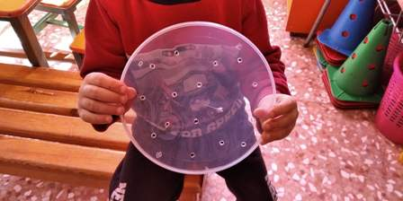
2. In the garden, take soil and place it on the bottom of the bowl.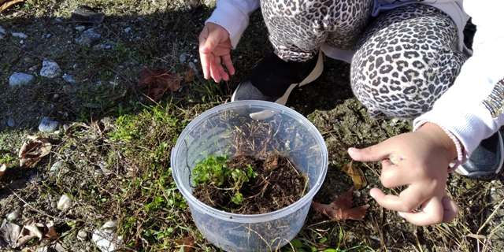
3. Also place small branches and leaves.
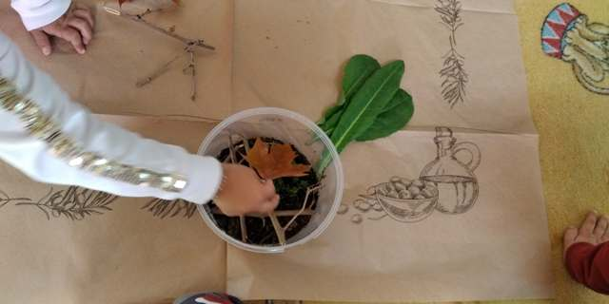
4. Look for snails.
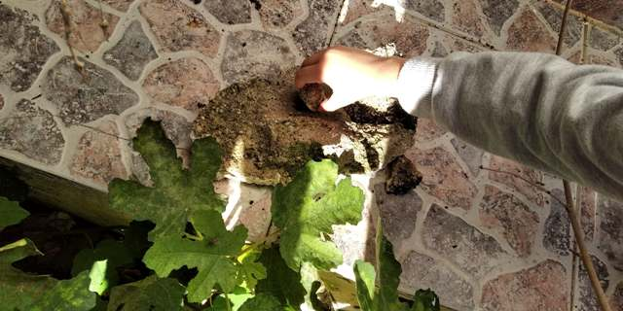

5. Place the snails in the bowl
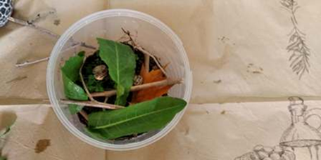

6. Moisten the soil with some water
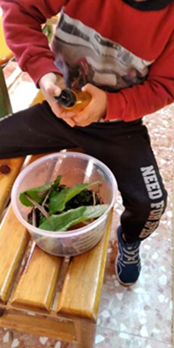

7. Close the lid.
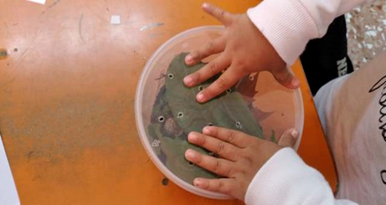

TIP: Do not forget to moisten the soil frequently and feed the snails with lettuce.
