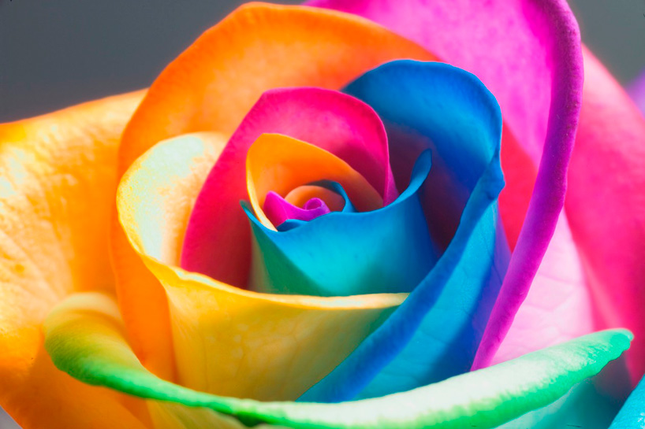

hey call me the ……… rose
But my ……… was Elisa Day
Why they call me it I do not ………….
For my name was Elisa Day
From the ……….. day I saw her, I knew she was the one;
she stared in my …………. and she smiled
For her lips were the colour of the …………..
That grew ………… the river, all bloody and wild
When he knocked on my ……….. and entered the room
My trembling subsided in his ………. embrace
He would be my first …….., and with a careful hand
He wiped up the that run down my face
On the second day I brought her a …………….
She was more ……………. than any woman I've seen
I said, 'Do you know where the wild roses ………….
So sweet and scarlet and …………?'
On the second day he ………… with a single red rose
Said: 'Will you give me your loss and …….. sorrow?'
I nodded my ……………, as I lay on the bed
'If I show you the roses ………… you follow?'
On the ………… day he took me to the river
He showed me the roses and we …………..
And the last ………….. I heard was a muttered word
As he knelt above me with a ……….. in his fist
On the last day I took her ……….. the wild roses grow,
she lay on the bank, the wind light as a …………
And I kissed her goodbye, said, 'All beauty must ……'
And I lent down and …………. a rose between her teeth

