René Goscinny**, Jean-Jacques Sempé**

Book Review

In this book Nikola wants to spend his summer holiday on an island, but his mother doesn’t want to. Fortunately, his dad wants, but he has to persuade his mother and he finally succeeds in doing it. When they arrive at the island they go to the beach, where Nikola meets a lot of friends. Some of them are stupid, some of them are smart. Together they play, they fight and they get in trouble, but they always come up with an idea and get away with it.

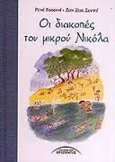 **Dipla Eufrosini**

***A CHRISTMAS STORY***

***Charles Dickens***

*Empenizer Skroutz is a lonely and stingy man. When his partner Marley dies, Skroutz refuses to pay for the funeral. Seven years later Marley appears as a spirit. From that day Skroutz changes his mind about life and he is not stingy and greedy any more.*

*I liked this book because it is about a mean man who was against Christmas but he finally changed his mind about life.*

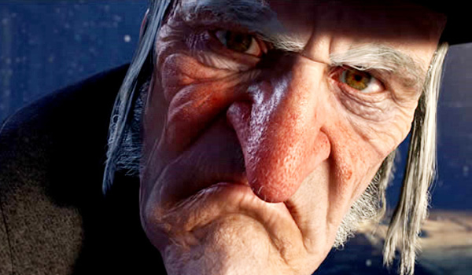

***George Potamitis***

***BOOK REVIEW: THE FAULT IN OUR STARS***

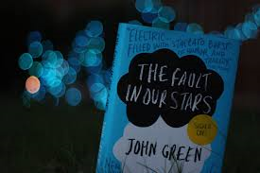

The book I’m going to talk about is called “The Fault in Our Stars”. The book is written by an author called John Green. Green is 36 years old and has written more than 4 books : Looking For Alaska, An Abundance Of Katherines, Paper Towns, Will Grayson-Will Grayson, The Fault In Our Starts and an extra book called “Let It Snow: Three Holiday Romance.” Green had a brother called Hank Green. Also, John is married and has a son called Henry and a daughter called Alice.

Now let’s talk about the book, shall we? The book is talking about a six-teen-year old girl that has cancer/a tumor and her parents convince her to go to a support group. There she meets a boy named Isaac. Isaac has his eye removed from cancer and now he is going to have his other one removed as well. Isaac introduces Hazel (the girl with the tumor) to Augustus Waters. Augustus is cancer free over a year. He has lost his one leg from cancer. Augustus invites her to come to his house so they can watch a movie. Hazel (Grace Nightcaster is his full name, I think) gives Augustus her favorite book, An Imperial Affliction. Augustus can see why she loves the book. The main character of the book is a girl suffering from cancer. She dies. That’s why the book has no ending. An organization called “The Genies” gives Augustus the opportunity to realize his wish so they can meet the author of the book and find out how the book ends. Augustus reveals to Hazel that’s his cancer is back and that’s his previous girlfriend died from brain cancer (It’s a really interesting part but I’m not going into details). When they get back from the trip Augustus gets worse. Two weeks later he dies. He leaves a letter for her. Meanwhile Hazel after Augustus’ death visits Isaac. The book ends with the line “I do Augustus, I do.”

Some quotes from the book are: “That’s the thing about pain, it demands to be felt.” Or my favorite one”It’s a metaphor, you put the killing think (the cigarette) between your mouth but if you don’t light it, it doesn’t have the power to kill you.” Augustus had always an unlighted cigarette between his lips.

Last but not least, Green was inspired to write this book because when he was younger his friend died from cancer when she was sixteen. Also, he got inspired when he was working in a children’s’ hospital.

The book is going to be a movie. The movie is going to be released on June 6th.

I really like this book because of its honesty. The book has a way to tell you to keep going. By keep going I mean don’t give up. They had the worst kind of cancer and they didn’t give up. The book is real. The book is beautiful.

[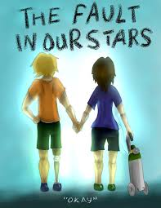](http://www.google.gr/imgres?safe=active&sa=X&hl=el&rlz=1T4GIGM_elGR520GR521&biw=1920&bih=856&tbm=isch&tbnid=nk1o9gqwNEbJTM:&imgrefurl=http://uluselsupermartf.info/book/the-fault-in-our-stars-wallpaper-8/&docid=Z4VxKsMBJKDwDM&imgurl=http://uluselsupermartf.info/wp-content/uploads/2013/05/the-fault-in-our-stars-wallpaper-nqab5t3e.png&w=786&h=1017&ei=-4UdU6vhJYfn4gSlr4HQAQ&zoom=1&ved=0CJcCEIQcMD4&iact=rc&dur=754&page=2&start=39&ndsp=50) [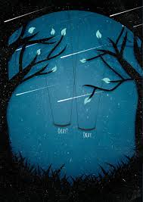](http://www.google.gr/imgres?safe=active&sa=X&hl=el&rlz=1T4GIGM_elGR520GR521&biw=1920&bih=856&tbm=isch&tbnid=6AsGpFhO9fFCEM:&imgrefurl=http://fishingboatproceeds.tumblr.com/post/32869552169/this-artwork-inspired-by-the-fault-in-our-stars&docid=NAChMhL0De6LKM&imgurl=http://25.media.tumblr.com/tumblr_mbdd7n9xt51qjhzvpo1_500.jpg&w=500&h=706&ei=-4UdU6vhJYfn4gSlr4HQAQ&zoom=1&ved=0CMkBEIQcMCQ&iact=rc&dur=277&page=1&start=0&ndsp=39)

***Katerina Genouzou***

***The fault in our stars***

*Author: Jonh Green*

*Released:* January 2012

Characters: Hazel Grace, Augustus Waters etc.

The book I am going to talk about called “The fault in our stars’’. The book talks about a girl named Hazel Grace who suffers from cancer and a guy named Augustus Waters who suffers from cancer as well. Hazel goes to a support group and meets a boy named Isaac. Isaac introduces Hazel to Augustus. They become friends and have a wonderful time together until Augustus reveals to Hazel that his cancer is back (p.s. Augustus had cancer and lost a leg because of it). Hazel sticks to Augustus until the time of his death. Meanwhile they developed a “secret” code the “OKAY”. When times are hard they keep saying to each other “OKAY”.

I like this book because it talks about a real story and because it is very dramatic!

[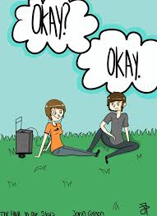](http://www.google.gr/imgres?safe=active&sa=X&hl=el&rlz=1T4GIGM_elGR520GR521&biw=1920&bih=856&tbm=isch&tbnid=rv5koDEq1LEuxM:&imgrefurl=http://www.deviantart.com/digitalart/paintings/?view_mode=2&order=9&q=the+fault+in+our+stars&docid=KvJZUYajrZhZmM&imgurl=http://th00.deviantart.net/fs70/PRE/i/2013/153/e/1/the_fault_in_our_stars_by_itstimefortea-d67lhed.png&w=762&h=1048&ei=-4UdU6vhJYfn4gSlr4HQAQ&zoom=1&ved=0CMABEIQcMCE&iact=rc&dur=608&page=1&start=0&ndsp=39)[](http://www.google.gr/imgres?safe=active&sa=X&hl=el&rlz=1T4GIGM_elGR520GR521&biw=1920&bih=856&tbm=isch&tbnid=om-ko8fzG6TbmM:&imgrefurl=http://the-fault-in-our-stars-quotes.tumblr.com/post/55698398625&docid=sMe0sr6n0iNp8M&imgurl=http://31.media.tumblr.com/b02dc22f75c6ff1d912580f210c25322/tumblr_mq393q3yUD1rvjgxgo1_500.gif&w=500&h=500&ei=-4UdU6vhJYfn4gSlr4HQAQ&zoom=1&ved=0CPwBEIQcMDU&iact=rc&dur=1073&page=2&start=39&ndsp=50)

**Matoula Karali**

**Fandom Duck**

Donald duck is a super hero who helps people when they are in danger. In this book Donald Duck helps his uncle Scrooge Mc Duckto find the thieves who stole his money.

[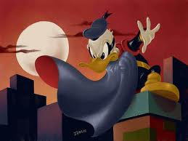](http://www.google.gr/url?sa=i&source=images&cd=&cad=rja&uact=8&docid=OaTNhpm_nVvxxM&tbnid=nAWnWewvXLiKyM:&ved=0CAgQjRw&url=http://www.flickr.com/photos/35399281@N04/3280093602/&ei=z5kdU6e9Ieaa4wSmtoC4CA&psig=AFQjCNG-ETzprc3bu_NQTfbl1pBQC03b1A&ust=1394535247589174)

**George Katsimigas**

**Prophet Madman Wanderer**

[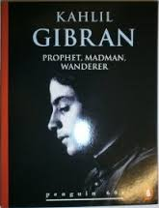](http://www.google.gr/url?sa=i&source=images&cd=&cad=rja&uact=8&docid=0Dwmfq224pS4YM&tbnid=R6_OEFbvphB4QM:&ved=0CAgQjRw&url=http://www.bookcrossing.com/journal/11966230/&ei=E54dU5O7A8Xj4QS82YDQCw&psig=AFQjCNF1YL2ASLIpWfVFN7-5ijJB15-m9Q&ust=1394536339153068)The author of this book is Kahlil Gibran (1883-1931), who is the main character too. He was born near the Mount Lebanon. He was a poet, a philosopher and an artist. He wrote a book about a Prophet who spoke to people of many things- work and play, possessions, crime, love and death. This collection includes The Prophet, which has been published in full by Penguin and Arkana, and extracts from The Madman and The Wanderer. I like this book because it’s an old book about a prophet and it’s a kind of historic book.

**Barbara Vitsa**

INHERITANCE CIRCLE

Inheritance circle is written by Christopher Paolini and consists of four books: Eragon, Eldest, Brisingr and Inheritance. All four books are about the same story. The story is the following one. A boy named Eragon found a blue stone as he was chasing. Nobody knew what kind of stone it was. One day the stone broke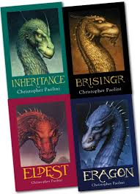 and revealed Eragon, a dragon. He was the first dragon-rider after many centuries. With the help of his dragon Safira, their friends and their alliance Eragon and Safira tried to defeat the Empire and kill the traitor for the death of all the dragon-riders.

I like these books because they are adventurous, they have action and they keep you in suspense.

Legatos Lefteris

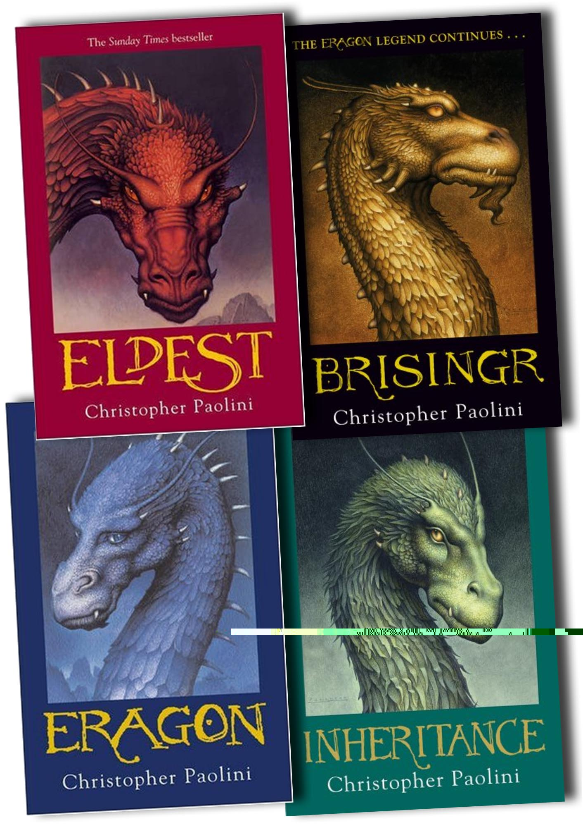

**Here, There be Dragons**

**Author:** James A. Owens  
**Main characters:** John, Jack, Charles  
**Other characters**: Bert, Aven, Bug, Mordred, Magwich, Tummeler, Ordoo Mag, Samaranth

When a bizarre murder brings together three strange men on a rainy day in London, none of them can imagine how much the world they knew until then will suddenly change. They find out that the three are now the managers of Imaginarium Geographica, an atlas containing all places mentioned in the myths, in the legends, in the tales and in traditions. Now they're being asked to protect the destiny of the real and imaginary world from the dark forces that threaten them. Soon, the three men will begin an exciting journey, full of magic and mystery, to the legendary worlds we have known through the famous stories of world literature fiction....

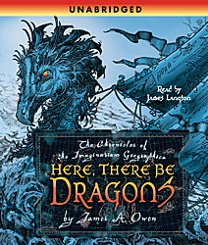 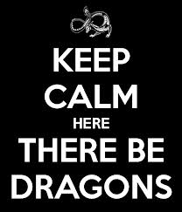

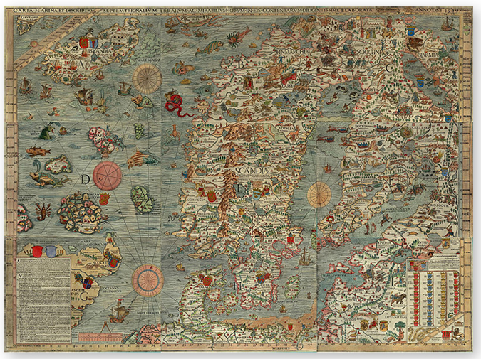

Mpampikis Panagiotis

**MOWGLI**The author of book is Randyarnd Kipling. The main character is a boy whose name is Mowgli. The book is about a little boy who grew up with some wolves in a jungle. He made friends and enemies between the animals. When he grew up he returned to the town and fell in love with a beautiful girl and they got married. They lived with their family in a house close to the jungle, happily ever after  
  
I like the book because when I was a baby my mother read it to me almost every night and it brings me memories.

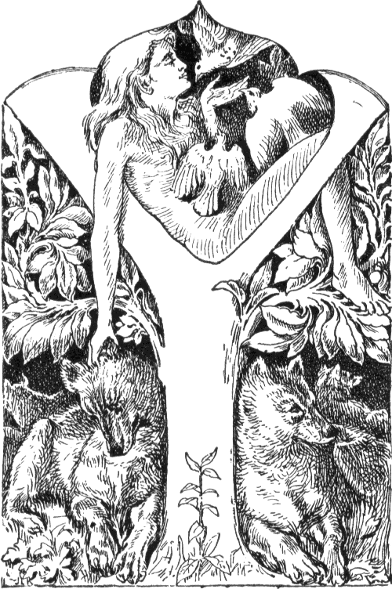

Vasilis Panagiotopoulos