

**EUROPEAN ART CENTER**

**AND INSTITUTE FOR EASTERN ROMAN EMPIRE RESEARCH STUDIES IN EUROPE**

Decision No 98/85 & 7975/08 of Court of First Instance of Athens ↑ Nb 2237 of Register of Cultural Institutions of Hellenic Ministry of Culture ↑ Programmatic partner and advisory entity of ASBMH - University of Pittsburgh ↑  Diploma of Honour of “Association Internationale des Critiques Litteraires” (A.I.C.L.-Paris) ↑ “Demosthenion” Medal and Diploma of Honour

of Paeanea’s Mayoralty

14 Α΄Anapaphseos Str. - 190 02 Paeanea Attika, Greece - Tel. (andFax): 210.66.43.854

<https://euarceblog.wixsite.com/euarce/about> * [www.euarce.com](http://www.euarce.com) - E-mail: [artcentr@otenet.gr](mailto:artcentr@otenet.gr)

P R E S S R E L E A SE

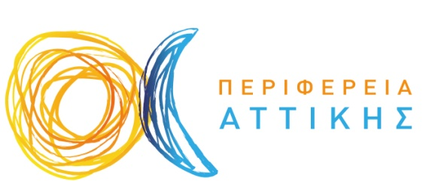

**Under the auspices of the Region of Attica**

**INTERNATIONAL POETRY COMPETITION**

**“The garden of** **cultural heritage”**

**ANNOUNCEMENT/NOTICE:**

On the occasion of the European Year of Cultural Heritage 2018 the the Board of European Art Center announce the International Competition of Poetry with a particular emphasis on “Cultural Heritage”.

**The thematic focus should be on poetry inspired by greek folk history and life. The language of the Competition is Greek.**

This first-in-kind Competition is also aimed at commemorating and honouring:

-220 years since the birth of the great Greek National poet Dionysios Solomos

The Competition is organized under the auspices of the Region of Attica and with the honorary collaboration and programmatic assistance of the American-Hellenic Foundation of Western Pennsylvania (AHFWP)- Hellenic Cultural Center and Heritage Museum

A five-member panel consisting of renowned personalities in literature will offer three awards and twenty distinctions at a formal Soiree which will take place in the year 2018 at the European Art Center in Paeanea, Attika, Greece.

**COMPETITION DETAILS:**

The competition is open to anyone irrespective of age, creed, nationality. We will give particular emphasis to submissions from students at the secondary, and early post-secondary education level.

Only one submission (attention:unpublished the poem) will be accepted from each participant.

The submission must not be more than two (2) pages in A4 format.

**The submissions must be sent electronically to euarceart@gmail.com as Word .doc, .docx, or Adobe .pdf files, or they can be sent by post to: EUARCE – Anapaphseos 14A’, 190 02, Paeanea, Attiki,**

**-2-**

**Greece. Should a hard copy be submitted by post, the signed original and three signed copies must be concurrently sent.**

Each submission (electronic or mailed) must be preceded by a cover page with the following information:

-Name - Profession/Expertise - Complete mailing address - telephone number - email address

-fax number (if available)

A submission fee of 15 euro must accompany all entries (mailed to the address above if submission is electronic) and this must be made on an international money order (bank or post) to the following:

**EUROPEAN ART CENTER (ΕΥΡΩΠΑΪΚΟ ΚΕΝΤΡΟ ΤΕΧΝΗΣ ΚΑΙ ΕΡ...)**

**NATIONAL BANK, IBAN: GR1301101610000016129650707 - SWIFT ΤΡΑΠΕΖΑΣ (BIC): ETHNGRAA**

The money order must state the full name of the submitter.

The submission fee will be used to cover some of the expenses associated with the costs of the Competition.

**The deadline date is the 2th of April, 2018**

All entries must be received by EUARCE by the deadline. In total, the Competition will recognize and award 26 entries.

*Paeanea, 10th of January, 2018*

**THE BOARD OF EUARCE**