Το λεξικό του καλοκαιριού

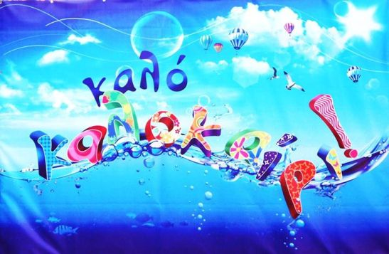

|  |  |
| --- | --- |
| Α,α | ακρογιαλιά |
| ÎÏÎ¿ÏÎ­Î»ÎµÏÎ¼Î± ÎµÎ¹ÎºÏÎ½Î±Ï Î³Î¹Î± Î±ÎºÏÎ¿Î³Î¹Î±Î»Î¹Î± Î½Î·ÏÎ¹Î±Î³ÏÎ³ÎµÎ¹Î¿ |  |

|  |  |
| --- | --- |
| Β,β | βερύκοκο |
| Αποτέλεσμα εικόνας για βερυκοκο |  |

|  |  |
| --- | --- |
| Γ,γ | γλάρος |
| ÎÏÎ¿ÏÎ­Î»ÎµÏÎ¼Î± ÎµÎ¹ÎºÏÎ½Î±Ï Î³Î¹Î± Î³Î»Î±ÏÎ¿Ï |  |

|  |  |
| --- | --- |
| Δ,δ | δελφίνι |
| ÎÏÎ¿ÏÎ­Î»ÎµÏÎ¼Î± ÎµÎ¹ÎºÏÎ½Î±Ï Î³Î¹Î± Î´ÎµÎ»ÏÎ¹Î½Î¹ |  |

|  |  |
| --- | --- |
| Ζ, ζ | ζέστη |
| ÎÏÎ¿ÏÎ­Î»ÎµÏÎ¼Î± ÎµÎ¹ÎºÏÎ½Î±Ï Î³Î¹Î± Î¶ÎµÏÏÎ· |  |

|  |  |
| --- | --- |
| Κ,κ | καρπούζι |
| ÎÏÎ¿ÏÎ­Î»ÎµÏÎ¼Î± ÎµÎ¹ÎºÏÎ½Î±Ï Î³Î¹Î± Î¶ÎµÏÏÎ· |  |

|  |  |
| --- | --- |
| Μ, μ | μαγιό |
| ÎÏÎ¿ÏÎ­Î»ÎµÏÎ¼Î± ÎµÎ¹ÎºÏÎ½Î±Ï Î³Î¹Î± Î¼Î±Î³Î¹Î¿ Î½Î·ÏÎ¹Î±Î³ÏÎ³ÎµÎ¹Î¿ |  |

|  |  |
| --- | --- |
| Π, π | παγωτό |
| ÎÏÎ¿ÏÎ­Î»ÎµÏÎ¼Î± ÎµÎ¹ÎºÏÎ½Î±Ï Î³Î¹Î± ÏÎ±Î³ÏÏÎ¿ |  |

|  |  |
| --- | --- |
| Φ,φ | φράουλα |
| ÎÏÎ¿ÏÎ­Î»ÎµÏÎ¼Î± ÎµÎ¹ÎºÏÎ½Î±Ï Î³Î¹Î± ÏÏÎ±Î¿ÏÎ»Î± |  |

|  |  |
| --- | --- |
| Ψ, ψ | ψάρι |
| Î£ÏÎµÏÎ¹ÎºÎ® ÎµÎ¹ÎºÏÎ½Î± |  |