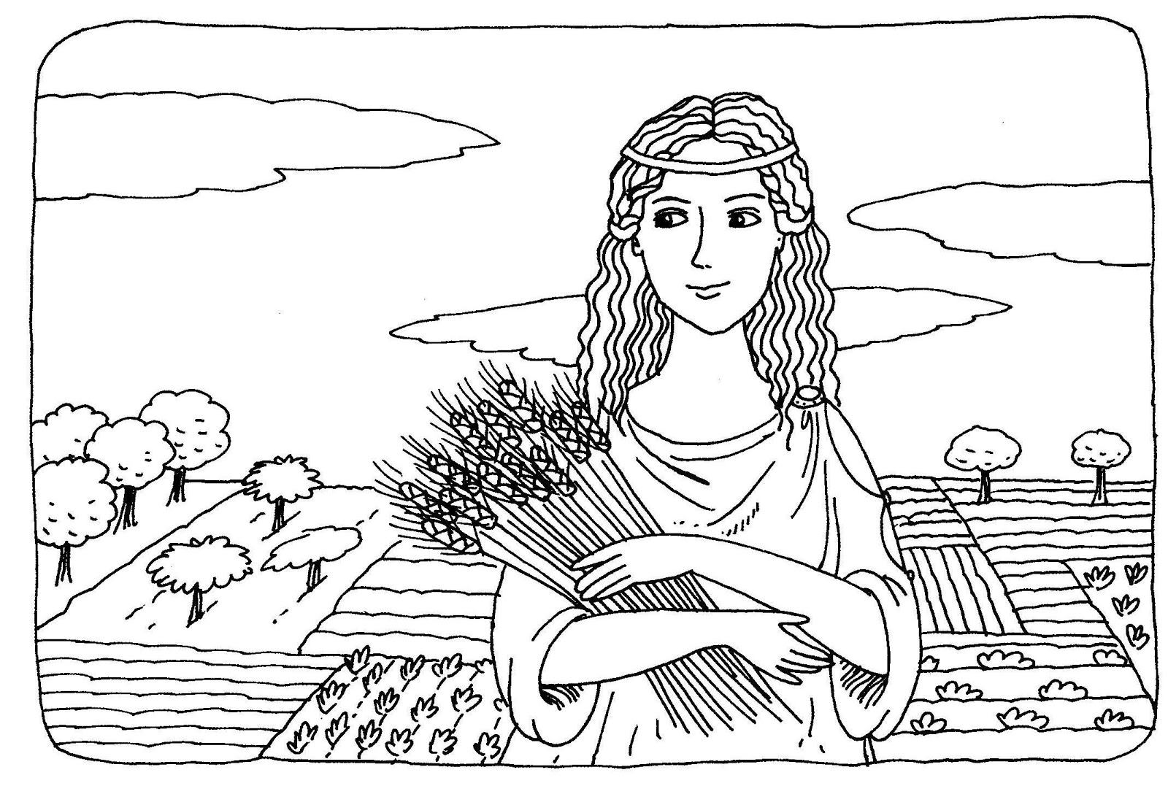

ΟΝΟΜΑ…………………………………………………………………………….. ΗΜΕΡΟΜΗΝΙΑ ……………………………………………………

Γράφω τη λέξη **ΔΗΜΗΤΡΑ**

|  |  |  |  |  |  |  |
| --- | --- | --- | --- | --- | --- | --- |
| **Δ** | **Η** | **Μ** | **Η** | **Τ** | **Ρ** | **Α** |
|  |  |  |  |  |  |  |