- A liter of oil


Match and complete

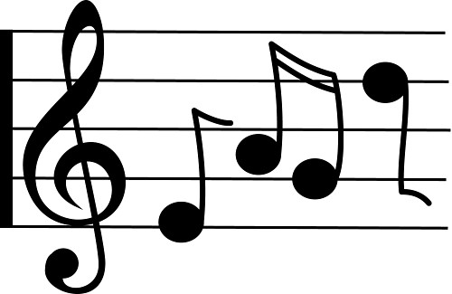

a grain of rice
a _________ of butter
a ___________of honey
a __________of bread
a __________ of music
a __________of water
a ___________ of oil
a ___________ of rain
a ___________ of flour
a _______ of furniture
a __________ of wine
a __________ of Coke
a __________ of milk
a __________ of sugar
a _____ of chocolate
a _____ of toothpaste
a ___________ of cake
a ___________ of tea

use the following words
1
packet liter piece can bottle tube
cartonbargrain
jar dropslice
loaf kilocup
glass piecelump

Fill in the blanks with how much / how many

_________________ sugar is there?
_________________ bars of chocolate did Mum buy?
_________________ milk do you need for the cake?
_________________ glasses of water did you drink?
________________ lumps of sugar do you put in your coffee?
________________ slices of pizza did he eat?
________________ rice did you prepare?
________________ butter is there in the fridge?
5
18
13

10
8
14

3
6
1

11
16
2

12
4
15

17
9
7
a grain of rice
a kilo of butter
a jar of honey
a loaf of bread
a piece of music
a glass of water
a liter of oil
a drop of rain
a packet of flour
a piece of furniture
a bottle of wine
a can of Coke
a carton of milk
a lump of sugar
a bar of chocolate
a tube of toothpaste
a slice of cake
a cup of tea

Fill in the blanks with how much / how many

How much sugar is there?
How many bars of chocolate did Mum buy?
How much milk do you need for the cake?
How many glasses of water did you drink?
How many lumps of sugar do you put in your coffee?
How many slices of pizza did he eat?
How much rice did you prepare?
How much butter is there in the fridge?

