 |  |  | 
Turn left (at…) | Turn right (at…) | Go straight on | Turn second left
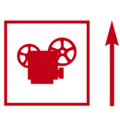 | 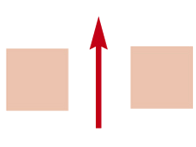 | 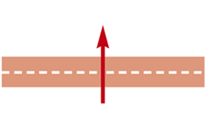 | 
Go past … | Go through | Cross the road | Turn second right
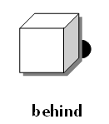 | 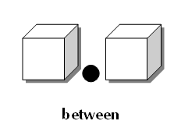 | 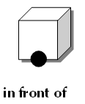
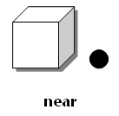 | 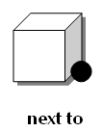 | 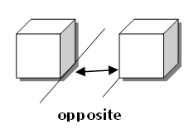

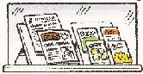 | 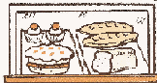 | 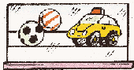 | 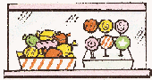 | 
NEWSAGENT’S | BAKER’S | TOY SHOP | SWEET SHOP | SHOPPING CENTRE
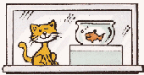 | 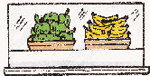 | 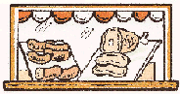 | 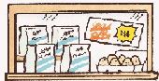 | 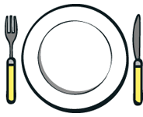
PET SHOP | GREENGROCER’S | BUTCHER’S | SUPERMARKET | RESTAURANT
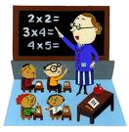 | 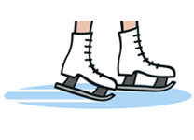 | 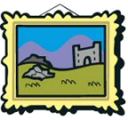 | 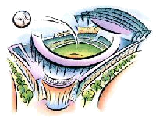 | 
SCHOOL | ICE RINK | ART GALLERY | FOOTBALL STADIUM | BOWLING ALLEY
 | 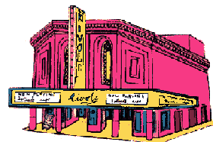 |  | 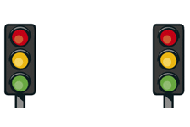 | 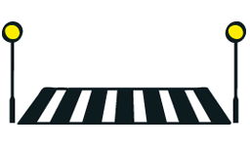
INTERNET CAFE | CINEMA | LIBRARY | TRAFFIC LIGHTS | ZEBRA CROSSING

1.- Look at these maps and write the correct order to go to the place.
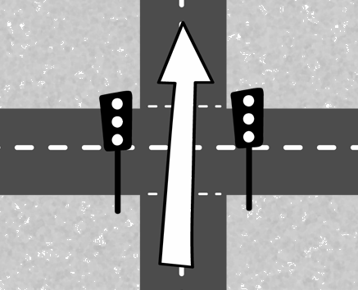 | 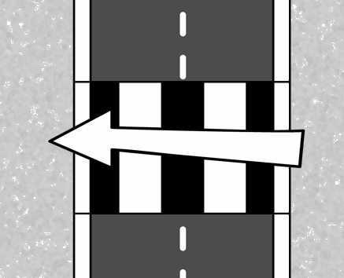 | 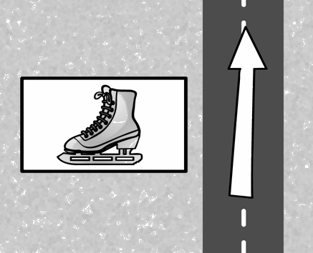 | 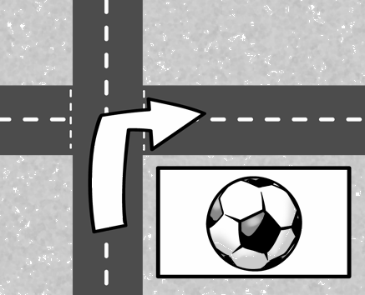 | 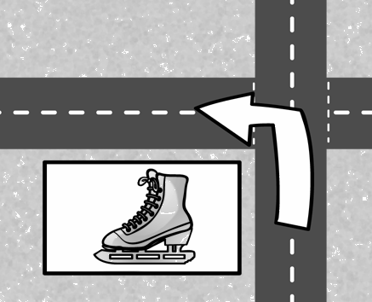
Go straight on at the traffic light. | Cross ...
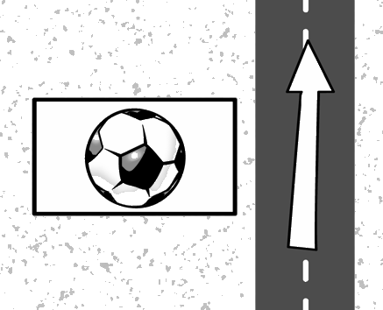 | 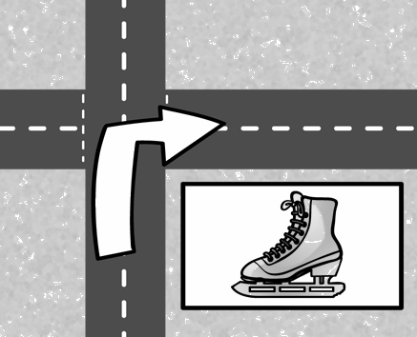 | 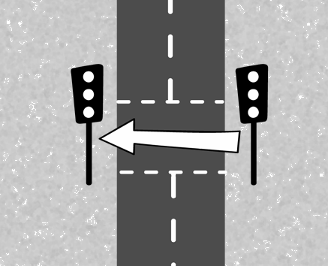 | 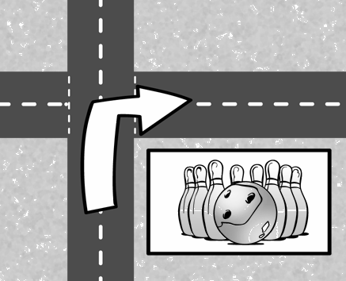 | 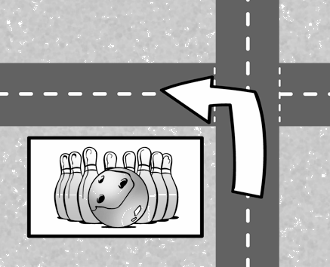
2.- Look at the map and answer the questions, using the preposition of place in brackets.

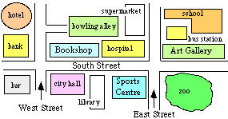
1.- Where is the library? (between)
It’s
2.- Where is the bowling alley? (behind)

3.- Where is the hotel? (next to)

4.- Where is the zoo? (opposite)

3.- Look at the map from exercise 2 and complete the sentences with the correct preposition.
- The hospital is ____________________________ the bookshop.
- The school is _________________________ the bus station.
- The bar is __________________ the bank.
- The bus station is ___________________ the school and the art gallery.
- The city hall is __________________ the library.

4.- Look at the two pictures and find differences. Write sentences using “There is / are”(affirmative or negative).
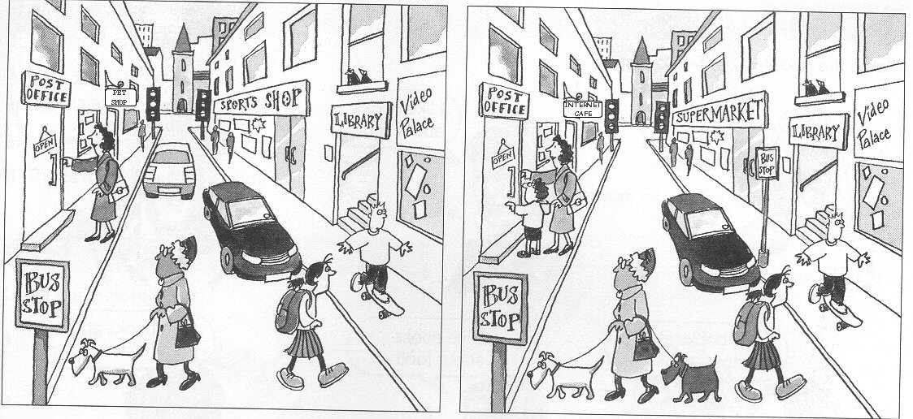

- In picture A,
In picture B,

5.- Look at this map and write the directions. You are at “X”.
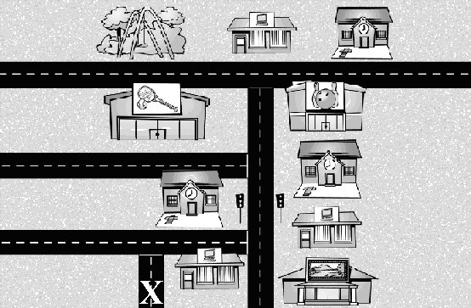

- A: Excuse me, can you tell me where the bowling alley is, please?
B: Yes.
A: Thank you very much.
B:

- A: Excuse me, is there a park near here?
B: Yes.
A:
B:

6.- Now, have a look at this map and write a complete dialogue. You are at the “X”.
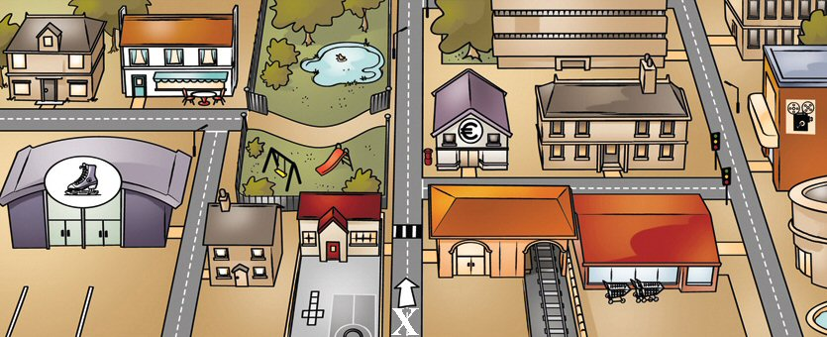

- (ask and give directions to go to the restaurant)
A:
B:
A:
B:

- (ask and give directions to go to the cinema)
A:
B:
A:
B:

