LOST IN A CITY (How to ask and give directions)

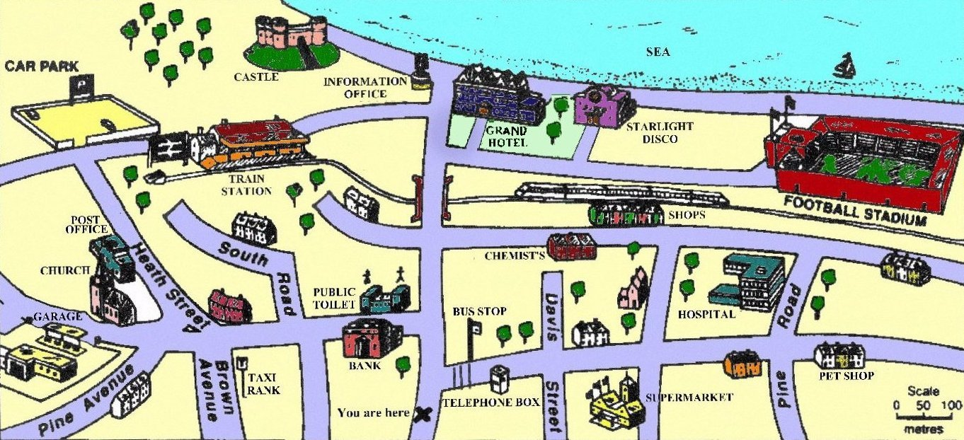

Asking for directions:
- Excuse me, where is the bank, please?
- Excuse me, is there a bank near here?
- Excuse me, can you tell me where the bank is, please?
- Excume me, how can I get to the bank, please?

Giving directions:

- Go straight on.
- Go straight ahead.
- Go along this street. / Go along Oxford street.
- Turn left / right (at the traffic light, at the zebra crossing, …).
- Turn first (second, …) left / right.
- Take the first (second) turning on the left / right.
- Go past the supermarket…
- Go across the bridge or Cross the bridge.
- Go through the park
- Go to the end of the street.
- It’s on your right / left.
- It’s next to …
- It’s opposite the…
- It’s not very far from here.
- You can´t miss it.
- It’s quite far from here. You should take a bus (taxi, …).
- I’m sorry. I’m no from here

 |  |  | 
Turn left (at…) | Turn right (at…) | Go straight on  Go along... | Turn second left  Take the 2nd turning on the left
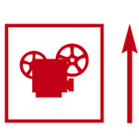 | 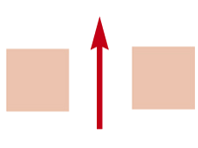 | 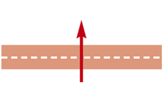 | 
Go past … | Go through | Cross the road | Turn second right
- Exercise: Where are you? Read, look at the map on the previous page and answer.

1) Go straight on. Turn first left and then turn second right. It’s on your left.
I’m at the ___________________________
2) Go straight on. Go across the bridge and turn first right. Go till the end of the street. => I’m at the ________________________
3) Go straight on. Go across the bridge and go straight ahead. Turn left at the end. Go past the information office. It’s on your left. I’m at the ________________

- Exercise: Complete the dialogues:

- How to get to the supermarket:
A: Excuse me, can you tell me how _________ to the nearer supermarket?
B: Yes. Go _____________ and turn first right. Go past the ________________ and turn second right. The supermarket is on the _______________. You can’t miss it.
A: Thank you very much.
B: That’s all right. Bye
A: Bye, bye

- How to get to the taxi rank
A: Excuse me, is there a _____ _______________ near here?
B: Yes. Go _____________ and turn first _______. Go past the ________________ and turn ________ left. The taxi right is on your _______________. You can’t miss it.
A: Thank you very much.
B: _________________. Bye
A: Bye, bye

- Exercise: Write new dialogues:

- Now, write more dialogues to go to some of these places:

- The public toilet
- The garage
- The hospital
- The train station
- The Starlight Disco
- The Car Park

- A: Excuse me, ________________________________________?
B:

A:
B:
A:

- A: Excuse me, ________________________________________?
B:

A:
B:
A:

- A: Excuse me, ________________________________________?
B:

A:
B:
A:

KEYS:

- Exercise: Where are you? Read, look at the map on the previous page and answer.

- Where am I?

1) Go straight on. Turn first left and then turn second right. It’s on your left.
I’m at the POST OFFICE
2) Go straight on. Go across the bridge and turn first right. Go till the end of the street. => I’m at the FOOTBALL STADIUM.
3) Go straight on. Go across the bridge and go straight ahead. Turn left at the end. Go past the information office. It’s on your left. I’m at the CASTLE.

- Exercise: Complete the dialogues:

- How to get to the supermarket:
A: Excuse me, can you tell me how TO GET to the nearer supermarket?
B: Yes. Go STRAIGHT ON and turn first right. Go past the BUS STOP and turn second right. The supermarket is on the RIGHT You can’t miss it.
A: Thank you very much.
B: That’s all right. Bye
A: Bye, bye

- How to get to the taxi rank
A: Excuse me, is there a TAXI RANK near here?
B: Yes. Go STRAIGHT ON and turn first LEFT Go past the BANK and turn SECOND left. The taxi right is on your LEFT You can’t miss it.
A: Thank you very much.
B: THAT’S ALL RIGHT. Bye
A: Bye, bye

- Now, write more dialogues to go to some of these places:

- The public toilet
- The garage
- The hospital
- The train station
- The Starlight Disco
- The Car Park

- A: Excuse me, is there a public toilet near here?
B: Yes. Go straight on and turn first left (or take the first turning on your left). The public toilet is on your right, opposite the bank.
A: Thank you very much.
B:That’s all right.
A: Goodbye.

- A: Excuse me, can you tell me where the train station is?
B: Sure. Go along this street. Cross the bridge and turn first left. Go straight on for about 500 metres and the train station is on your left. You can’t miss it!
A: Thank you very much!
B: You’re welcome.
A: Bye!

- A: Excuse me, can you tell me where the Starlight Disco is, please?
B: Yes. Go straight on, go across the bridge and take the first turning on your right. Go past the hotel and the disco is on your left, next to the hotel.
A: Thank you very much!
B: You’re welcome.
A: Bye!

