**ASKING AND GIVING DIRECTIONS**

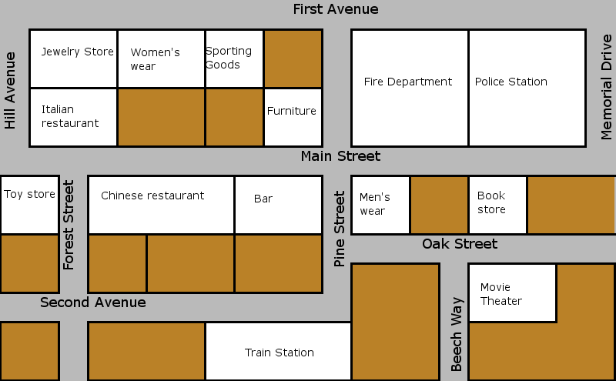

Hospital

Museum

Gas

Station

Parking lot

News

stand

Clothing Store

Bus

stop

Super

market

Dry Cleaners

Cal’s Cafe

Pharmacy

Church

Bank

Park

School

Library

⚫ **YOU ARE HERE**

1. **True or false**
2. The school is next to the pharmacy T F
3. The bar is on the corner of Main St and Pine St. T F
4. The police station is next to the Fire Department T F
5. The toy store is across from the Chinese Restaurant T F
6. The pharmacy is between the trains station and the hospital T F
7. The hospital is across from the parking lot T F
8. The neswsstand is between the library and the clothing store T F
9. Cal’s Cafe is on the corner of Hill Ave. and Main St. T F
10. The movie theater is next to the dry cleaners T F
11. The gas station is across from Cal’s café.

2) Give directions

A: Excuse me. Where’s the supermarket?

You: The supermarket? Go _______ on ____________________ turn __________ on __________ it’s __________ from the museum.

A: Thank you!

You: ____________________.

A: Excuse me. Where’s the bank?

You: Go __________ on __________ turn __________ on __________ and turn __________ on __________ and again turn __________ on__________. The bank is __________ the Italian restaurant and the bus stop.