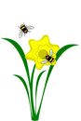

1
2

Fill in the crossword and find the hidden words.

1
2

3
4
5
6
7
8
9
10
11
12
13
14
15
16
17
18
?
19
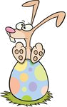
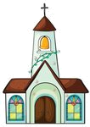
3
5
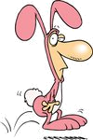
4

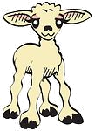

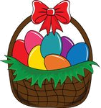
6
7
8

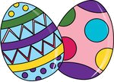

10
12

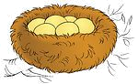
9

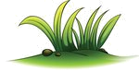

11
13

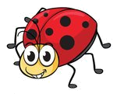
14


17


18


16
19
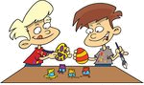
15

D
A
F
D
O
L
I
1
F
T
S
E
O
B
N
N
2

N
N
U
Y
B
3
H
P
O
4
H
C
R
C
H
5
U
L
A
M
B
6
I
L
U
T
S
P
7
B
K
E
A
S
T
8
E
N
T
S
9
E
A
E
T
S
E
R
S
G
G
10
S
S
G
R
A
11
E
G
R
E
12
I
T
G
N
H
C
I
K
C
13
A
D
Y
U
14
G
B
L
P
N
A
T
I
15
H
T
L
O
A
16
G
E
E
G
C
O
C
D
N
O
I
E
O
T
R
C
A
17
N
S
U
S
B
18
S
H
T
O
C
R
O
?
R
G
N
I
19
S
P

