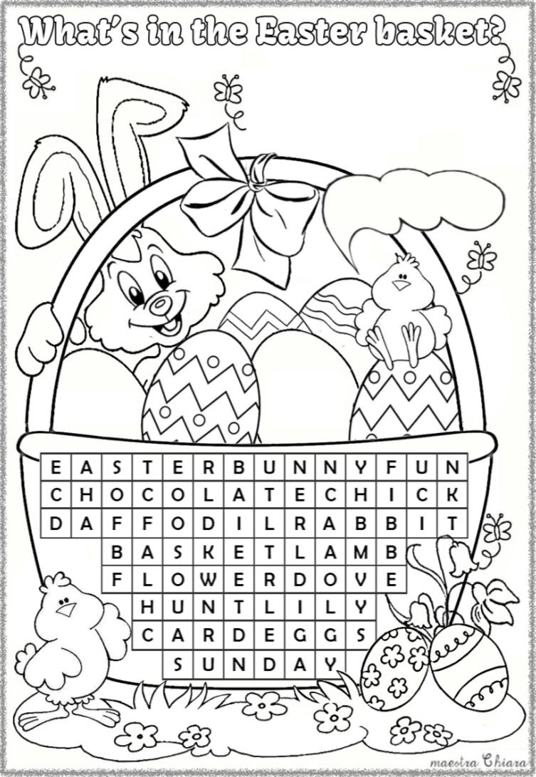
Colour:
the bow red and the basket - brown;
the Easter Bunny - pink and grey;
the chicks - yellow and orange;
the eggs and the flowers as you want.
Can you find these words
in the word-search below?
chick
fun - eggs
daffodil
chocolate
flower
basket
lamb - card
rabbit - hunt
easter bunny
sunday - lily
dove

