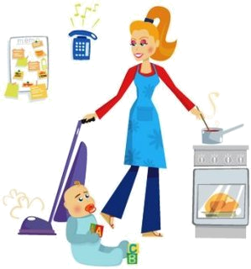
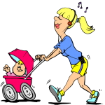
HE He likes football.
SHE She gets up early.
IT It swims very fast.
MY MOTHER’S DAILY ACTIVITY
ACTIVITIES TIME
0. get up at seven o’clock.
1. set the table at half past seven.
2. have breakfast at eight o’clock.
3. wash the dishes after breakfast.
4. clean the house before lunch.
5. cook the meal after lunch.
6. do the shopping in the afternoon.
7. have diner at seven. (p.m.)
8. watch TV after dinner.
9. do the ironing in the evening
10. go to bed at ten. (p.m)

V+s


MY MOTHER’S DAILY ACTIVITY
ACTIVITIES TIME
0. My mum gets up at 7.00
1 My mum .................................... at 7.30
2. She ............................................. at 8.00
3. She .............................................. after breakfast.
4. She .............................................. before lunch.
5. She............................................... after lunch.
6. She .............................................. in the afternoon.
7. She ............................................. at 7 p.m.
8. She .............................................. after dinner.
9. She .............................................. in the evening.
10. She ............................................. at 10 p.m.

REWRITE THE SENTENCES
1. I go to school at 8 o’clock. (He)
.................................................................................
2. We play basketball on Saturdays. (Tim)
....................................................................................
3. I watch TV in the afternoon. (She)
.........................................................................................
4. They visit their friends in the afternoons. (My mum)
...............................................................................................
5. I have dinner at 7.30 (He)
...................................................................................................

6. My mother gets up very early. (They)
....................................................................................................
7. My brother does his homework in the evening. (I)
....................................................................................................
8. She cleans the house after lunch. (We)
......................................................................................................
9. My mother does the shopping in the afternoon. (They)
........................................................................................................
10. My brother brushes his teeth before bed. (I)
..........................................................................................................

