Adverbs of Frequency
1. We use adverbs of frequency to say how often something happens.
2. We normally put an adverb of frequency
after the verb be. He’s often late for school.
before most other verbs. You never phone me.
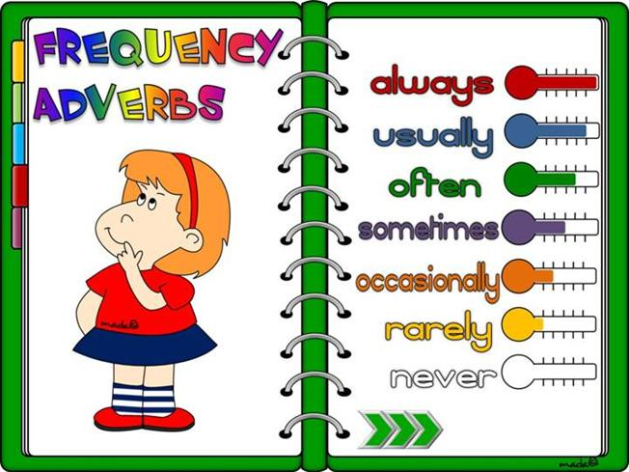
(exercises)

1) Complete the chart with the adverbs of frequency given in the box.
sometimes usually always hardly ever often never rarely occasionally

0%
100%
100%
100%
1_____ 2_________ 3_______ 4__________ 5__________ 6 _______ 7_________ 8__________

2) Put the words in the correct order to make sentences.
1. go swimming / sometimes / on Sundays / I
_______________________________________
2. in our house / cold / it’s / often
_______________________________________
3. usually / is / hungry / Sam / after school
_______________________________________
4. goes / never / my cousin / cycling
_______________________________________
5. Mark and Ted / books / hardly ever / read
_______________________________________
6. I / my homework / in my room / do / always
_______________________________________
7. snows / in this area / rarely / it
_______________________________________
3) Rewrite the sentences. Use the adverbs of frequency in brackets.
1. I’m late for school in the morning. (rarely)
__________________________________________
2. Sam goes out with his friends. (occasionally)
__________________________________________
3. Ann surfs the Net in the evening. (usually)
__________________________________________
4. My best friend takes photos at school. (never)
__________________________________________
5. They are at home in the evening. (often)
__________________________________________
6. Ted reads magazines about fashion. (hardly ever)______________________________________
7. We speak English in English classes. (always)
__________________________________________

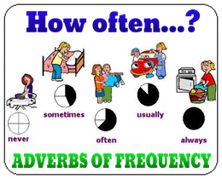
5) Work in pairs. Ask and answer questions. Tick your partner’s answers.
Are you in tune?QUIZ
How often
1. … do you listen to classical music?
a) Often b) Sometimes c) Rarely d) Never
2. …do you sing in the bath or shower?
a) Rarely b) Sometimes c) Never d) Often
3. … do your parents listen to the same music as you?
a) Never b) Sometimes c) Often d) Rarely
4. … do you listen to music while you are doing your homework?
a) Often b) Sometimes c) Rarely d) Never
5. …do you buy CDs?
a) Never b) Sometimes c) Rarely d) Often
6. … do you go to live concerts?
a) Often b) Sometimes c) Rarely d) Often
7. … do you play the piano / the guitar or other musical instruments?
a) Never b) Sometimes c) Rarely d) Often

4) Write questions. Use How often….? Then write true answers with frequency adverbs.
1. you / surf the Net?______________________
_______________________________________
2. you / play board games?________________
_______________________________________
3. you / listen to music ?___________________
_______________________________________
4. your best friend / call you ? _____________
_______________________________________
5. your grandparents / use a computer? _____
_______________________________________
_______________________________________
6. your mum / do the shopping ?___________
_______________________________________
_______________________________________
7. you / do the washing-up ? _______________
_______________________________________
8. your English teacher / speak Chinese ?
_______________________________________
_______________________________________

