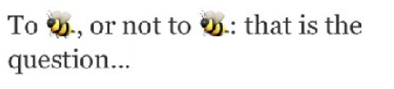
Say in with Emojis!!!
- Nerd  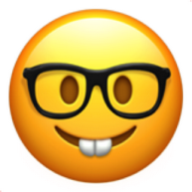 | - Blow a Kiss  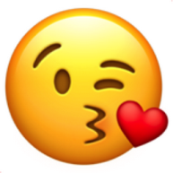 | - Thinking  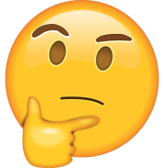 | - Pinocchio  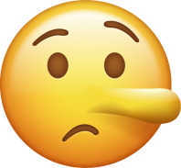 | - Joy  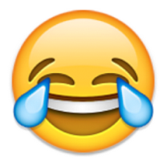
- Heart Eyes | - Sunglasses | - Horrified  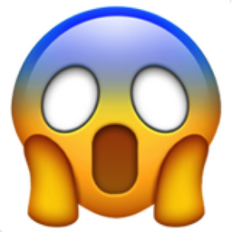 | - Alien | - Blush
- Sick  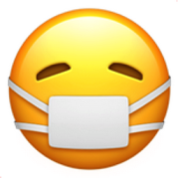 | - Unamused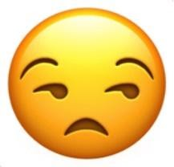 | - No mouth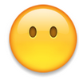 | - Wink | - Yum
Which Emoji would you use to reply to the following? Draw the correct Emoji or write the letters in the circles.
- Your complements are embarrassing. | ⃝
- I think that is just great! Good for you! | ⃝
- Oh, I’m madly in love with this kitten! | ⃝
- I am feeling a bit under the weather. I can’t talk to you now. | ⃝
- You’ve been such a faithful friend to me. Thank you so much for the favor. | ⃝
- LOL! I’m so excited and glad that I’m on the verge of bursting into tears. | ⃝
- I am never watching a horror movie again! | ⃝
- Mmm, delicious. The pizza was perfect. The cheesecake was ideal. | ⃝
- I’m cool, yeah. Or the sun is just too bright! | ⃝
- Not funny! | ⃝
- Well, to be honest that story is not exactly true! | ⃝
- Emm….Emm…. Well…. | ⃝
- No-no. Don’t ask me. I know nothing. | ⃝
- You don’t know who Bill Gates is? Are we from the same planet? | ⃝
- I have just finished my homework! | ⃝

KEY
- Your complements are embarrassing. = blush
- I think that is just great! Good for you! = wink
- Oh, I’m madly in love with this kitten! = heart eyes
- I am feeling a bit under the weather. I can’t talk to you now. = sick
- You’ve been such a faithful friend to me. Thank you so much for the favor. = blow a kiss
- LOL! I’m so excited and glad that I’m on the verge of bursting into tears. = joy
- I am never watching a horror movie again! = horrified
- Mmm, delicious. The pizza was perfect. The cheesecake was ideal. = yum
- I’m cool, yeah. Or the sun is just too bright! = sunglasses
- Not funny! = unamused
- Well, to be honest that story is not exactly true! = Pinocchio
- Emm….Emm…. Well…. = thinking
- No-no. Don’t ask me. I know nothing. = no mouth
- You don’t know who Bill Gates is? Are we from the same planet? = alien
- I have just finished my homework! = nerd

