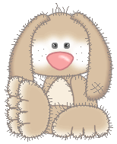
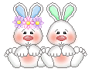
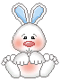
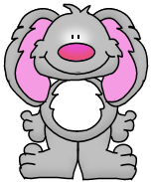
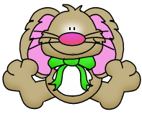
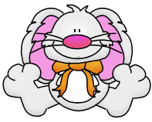
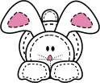


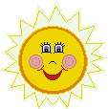
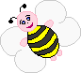
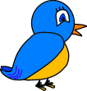
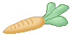
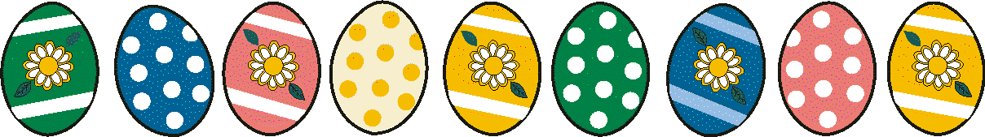
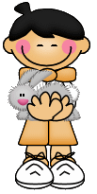
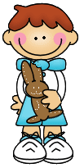
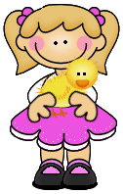
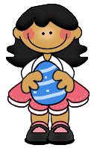

1. The bunny got paint on his mouth and in his eyes.
□ true □ false
3. The paint pot fell down from the chair.
□ true □false
6. The bunny was very sad.
□ true □ false
7. Grasses and flowers
were on the eggs now.
□ true □ false
8. The eggs looked like a
rainbow.
□ true □ false
There was once a small, clumsy Easter Bunny. When painting the eggs he dropped the brush, or sometimes he got paint on his nose and on his ears. He finally had a red nose, a yellow or green ear, one blue and one white leg and a
purple tail. All the other bunnies were laughing
when they saw him, "Hahahaha, you've got a red nose,"
or "You've got a yellow ear!" they laughed. At the end of it the paint pot fell on the ground and there was a large colourful puddle. “Oh dear”, cried the little bunny. And then he crashed into the table and all the
eggs that he had already painted, fell down into a colourful
puddle. Fortunately the eggs were not broken, because the
forest ground was soft with moss and grasses. Again, the other rabbits laughed at the poor little clumsy bunny, and he was crying for a long time. But when he started to put the eggs back
into the basket, he saw that the eggs had become very
beautiful in the colourful puddle. The eggs looked like
a colourful rainbow. Small grasses and flowers were on some
eggs and under the grasses and flowers they remained white.
The others bunnies stopped laughing and were very quiet when they saw how beautiful the eggs were. They really admired these awesome eggs.
On Easter Sunday the children looked for the Easter eggs and enjoyed the beautiful rainbow colours and the grasses and flowers on them.
The little clumsy Easter Bunny was sitting behind a bush and smiled.

Answer the questions!

1. On which parts of his face was paint?
………………………………………………………………………
2. What did he use for painting the eggs?
…………………………………………………………………….
3. Where did the paint pot fall to?
………………………………………………………………..
4. Where did the bunny put the eggs?
…………………………………………………………….
5. Why was the bunny crying for such a long time?
………………………………………………………………………………………………………
6. Where did he sit when watching the kids?
…………………………………………………………………………………………….
7 7. What are the colours of a rainbow?
………………………………………………………………………………………………………

Tick off „true“ or „false“.

Fill in the missing letters!
T_ _ _ e w_ _ o_ _e a s_ _ _ l, c_ _ _ _ y E_ _ _ _ _ B_ _ _y.
H_ p_ _ _ _ _ d e_ _ .
H_ h_d p_ _ _t on h_ s n_ _e a_ _ on h_ _ e_ _ s.
T_ _ o_ _ _ r b_ _ n_ _ s w_ _ e l_ _ _ _ _ _ g.
T_ _ e_ _ _ f_ _ l i_ _ o a
c_ _ _ _ _ _ _ l p_ _ d_ _ .
T_ _ b_ _ n_ p_ _ t_ _ e_ _ _
i_ _ _ a b_ _ _ _ t.
T_ _ e_ _ _ l_ _ _ _ d
l_ k_ a r_ _ _ _ _ w.

4. All the eggs fell into the
puddle and broke.
□ true □ false
2. The other bunnies were laughing about him.
□ true □ false
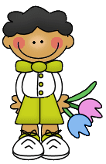
KEY
3. The paint pot fell down from the chair.
□ true □false
6. The bunny was very sad.
□ true □ false
4. All the eggs fell into the
puddle and broke.
□ true □ false
7. Grasses and flowers
were on the eggs now.
□ true □ false
8. The eggs looked like a
rainbow.
□ true □ false
1. The bunny got paint on his mouth and in his eyes.
□ true □ false
2. The other bunnies were laughing about him.
□ true □ false
Answer the questions!

1. On which parts of his face was paint?
On his nose, his eyes and legs.
2. What did he use for painting the eggs?
A brush.
3. Where did the paint pot fall to?
To the ground.
4. Where did the bunny put the eggs?
Into a basket.
5. Why was the bunny crying for such a long time?
Because the other bunnies were laughing and he was sad.
6. Where did he sit when watching the kids?
Behind a bush.
7. What are the colours of a rainbow?
Red, orange, yellow, green, blue, indigo, and violet.

Tick off „true“ or „false“.

Fill in the missing letters!
There was once a small, clumsy Easter Bunny.
He painted eggs.
He had paint on his nose and on his ears.
The other bunnies were laughing.
The eggs fell into a colourful puddle.
The bunny put the eggs into a basket.
The eggs looked like a rainbow.

