WORKSHEET

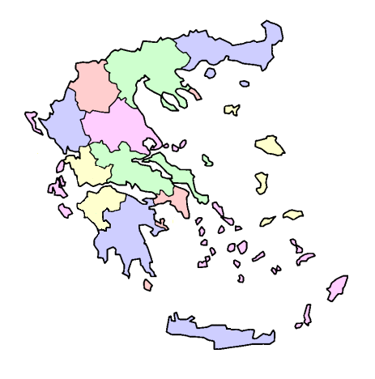

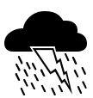
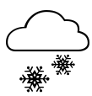


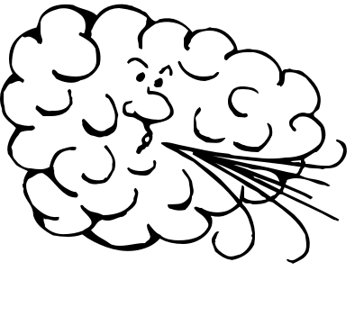


In groups, look at the photocopy taken from www.meteo.gr. Choose a city and find what the weather is like today. Write the symbols on the map of Greece in your worksheet. Then imagine you work for THIRIO TV. Write the weather report and present it on TV.
●ATHENS
●THESSALONIKI
●IOANNINA
●IRAKLIO
●XANTHI
●HANIA
●SPARTI
●RHODES
●PATRA
This is today’s weather report from THIRIO TV.
In ………………………… it ….………….………………………..and…………………………………………………………
●FLORINA
●MYTILINI
WEATHER SYMBOLS

