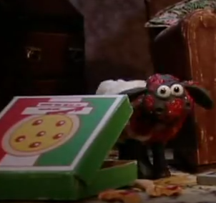Little sheep of Horrors

* 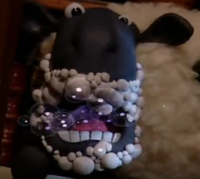Watch an interactive video at <https://en.islcollective.com/video-lessons/shawn-the-sheep-little-shop-of-horrors> and answer the questions you see in it.
* At the end of the story Shaun and Bitzen open the living room door and they see ….. …. Use your imagination to give a different ending to this episode.

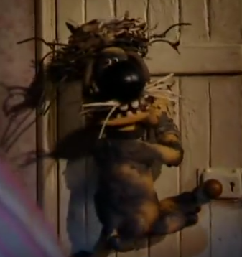

________________________________________________________________________________________________________________________________________________________________________________________________________________________

* The farmer is terrified. There is someone – a stranger – on his farm so he calls the police. Write a short dialogue between the farmer and the police officer talking on the phone. Make more speech bubbles if you want.

