**W A N T E D**

We are looking for this dangerous creature! Can you help?

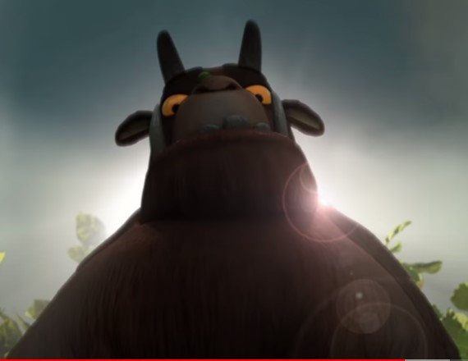

**Name** : __________________________________________________________

**Wanted for** : (e.g. eating other animals? / destroying the forest?)________________________________________________________

___________________________________________________________________

**Last seen on** (where? / When?) ________________________________________________________

**Description**: (physical appearance and character) ________________________________________________________

___________________________________________________________________

___________________________________________________________________

___________________________________________________________________

**Reward if found** :(αμοιβή) _____________________________________________

**Be careful! Extremely dangerous!!**