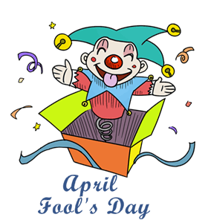
APRIL FOOLS’ DAY

- Read the text about the history of April Fools’ Day:
April Fools’ Day is an annual custom which probably started in France in 1564. The king of France changed New Year’s Day from April 1st to January 1st, but some people continued to celebrate the beginning of the year on April 1st. The rest of the people played jokes on them and fooled them with lies.
January was the winner but this strange custom travelled to other countries as well and people called “April Fools’ Day”.
We still keep this custom and every year on April 1st we do something silly or funny. It is celebrated in many countries around the world like UK, France, Canada, USA and people do pranks to fool the others. In Scotland, April Fools' lasts two days. Victims of pranks(=φάρσα) are called gowks (cuckoo birds).
(text taken from Funway ST’ coursebook)
- Find the words in the text which mean:
- the beginning of the year ………………………………………………..
- something that happens every year ……………………………………...
- to go from place to place …………………………………………………
- we listen to them and laugh ……………………………………………..
- not the truth ……………………………………………………………..
- we do these to other people to fool them and laugh …………………….

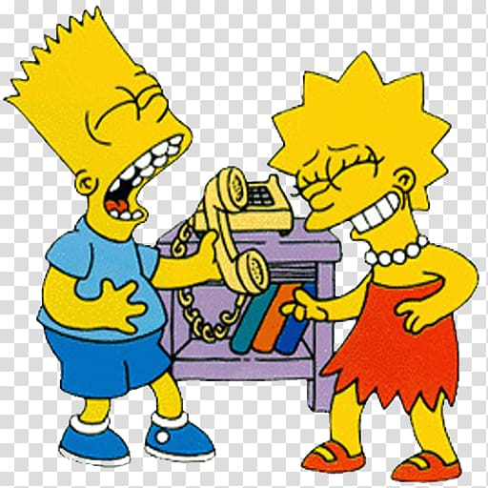
- Do a quiz about April Fools’ day at quizizz.com/join?gc=410948 . If this link doesn’t work try https://quizizz.com/admin/quiz/5e8485412f6c9a001ff4453b.

- How many words can you make with APRIL FOOLS’ DAY? Το κάθε γράμμα το χρησιμοποιείς σε κάθε λέξη που σχηματίζεις τόσες φορές όσες υπάρχει στη φράση π.χ. a is two times so you can use it twice in one word. Good luck!

_______________________ _______________________
_______________________ _______________________
_______________________ _______________________
_______________________ _______________________
_______________________ _______________________

