Exercise 1) Complete the postcard with the Present Continuous, Present Simple and Simple Past of the verbs in brackets.

lllhhhhhhhh
Dear Jasper,  Greetings from Scotland! I think Edinburgh …………………… (be) the _________________ city in Britain. We …………………….(stay) in a ___________________ hotel in the centre, near the castle. It’s quite ______________ but _____________ than in London. The people here are ______________ and ________________, too. We ………..….………… (visit) the castle and Holyroodhouse last week. Yesterday we ………..………….. (go) to Edinburgh zoo and did some shopping. The Royal Mile has lots of souvenir shops that …..………..... (sell) ______________ Scottish souvenirs. I really ……………….….. (love) the food here. There are _____________ cafés everywhere that …….…..……… (serve) _______________ cakes. The only problem is the weather. It’s _____________ and it …………………..… (rain) a lot.  See you soon,  Cecil | 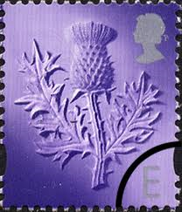  Jasper Watts  _________________  8 Hills Street  _________________  Cardiff CF10 2EF  _________________  Wales  ________________  UK  _________________

Exercise 2) Complete the blue gaps in the postcard with the adjectives and phrases from the list below:
much friendlier - cold - much cheaper - most beautiful – traditional – delicious -small but comfortable - very cosy - more helpful – expensive
