THESSALONIKi
Thessaloniki is a big city. Many people live in the city. There are a lot of musuems which tell as the history of the world.
Walking down the streets you can see many statues. Nearby the sea we can visit the white tower. On the top of it the view is wonderful. We can go for a short trip in the sea, with little boats. So this is my city and I love it so mush.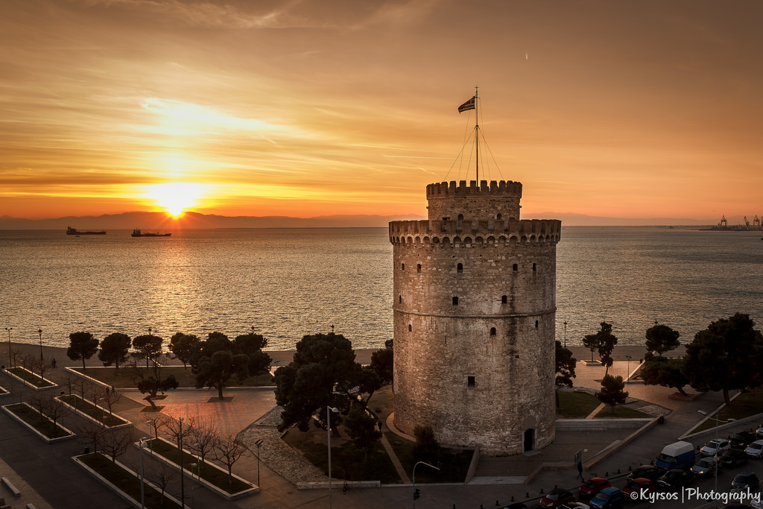
Elektra

