**SUBJECT:POLYGYROS**

**BY JIM AND CHRYSA**

**CLASS E1**

**Polygyros** is a town and [municipality](https://en.wikipedia.org/wiki/Communities_and_Municipalities_of_Greece) in [Central Macedonia, Greece](https://en.wikipedia.org/wiki/Central_Macedonia). It is the capital of [Chalkidiki](https://en.wikipedia.org/wiki/Chalkidiki" \o "Chalkidiki).It is built in the shape of an amphitheatre on a plateau on the south west side of the mountain [Cholomontas](https://en.wikipedia.org/wiki/Cholomontas" \o "Cholomontas). The municipal unit has a population of 10,721 inhabitants. It is 587 km north of Athens and 67 km SE from Thessaloniki.

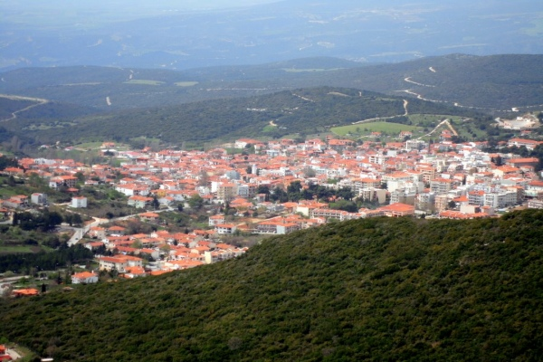

The climate is mild Mediterranean and has long-lasting sunshine.   
All kinds of agricultural activities and crops are cultivated, with today's olive cultivation.

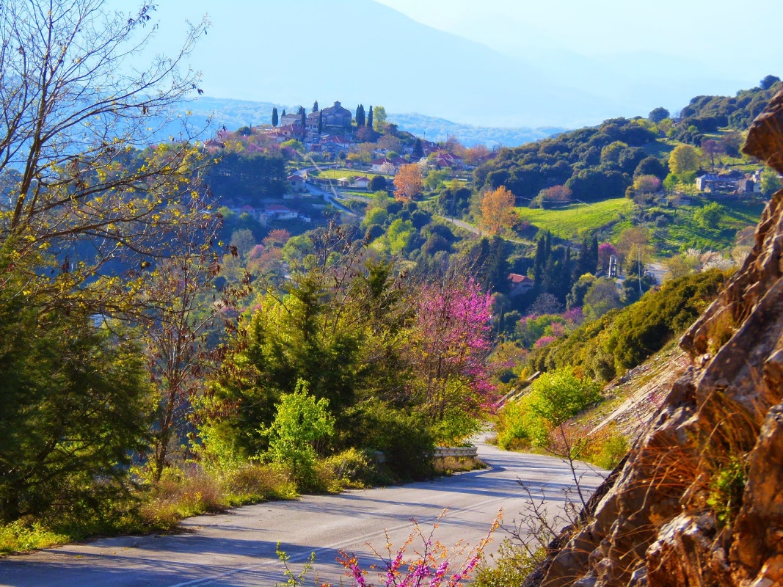

The Revolution of Chalkidiki began in Polygyros on 17 May 1821.

The Archaeological Museum of Polygyros has exhibits from all over Halkidiki. There is also a [Folklore Museum](https://en.wikipedia.org/wiki/Folklore_Museum_(Polygyros)) in the town, opened in 1998.

Polygyros is famous for its [carnival](https://en.wikipedia.org/wiki/Carnival) celebrations, which attracts visitors from all over [Greece](https://en.wikipedia.org/wiki/Greece).

