Your friend Emma from London is planning to come to Athens this summer and wants to visit the Acropolis Museum. You have recently visited the museum on a school trip and were impressed by what you saw. Write an **e-mail** (70-100 words) to your friend giving her some information about it and explaining why you liked it.

Use ideas in the IDEAS BOX to write the e-mail.



Go to <http://www.theacropolismuseum.gr/en/content/useful-information> and click on the following to find all the information you need.

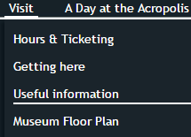

**IDEAS BOX**

* where it is
* when it is open
* what times it is open
* how much admission is
* what is / is not allowed in the museum
* what you can see there
* what you can buy at the gift shop
* why you liked it

