[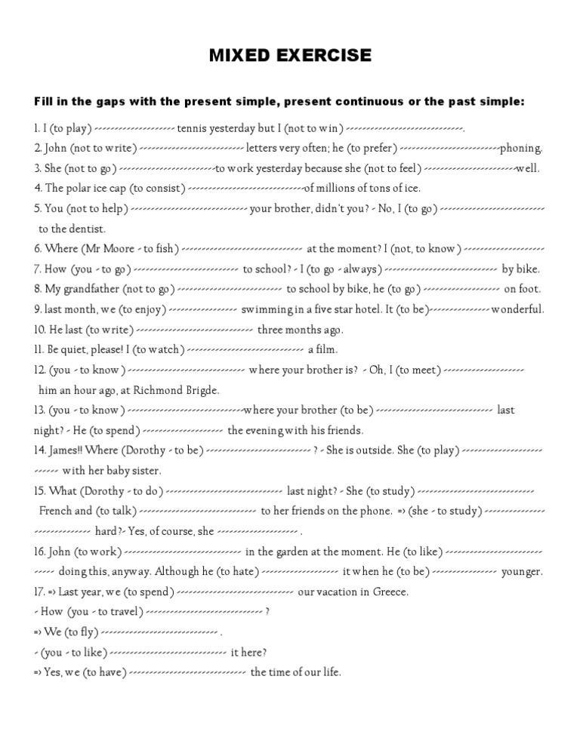](https://www.google.gr/url?sa=i&url=https%3A%2F%2Ffr.scribd.com%2Fdoc%2F116168558%2FMIXED-EXERCISE-The-Present-Simple-Present-Continuous-or-the-Past-Simple&psig=AOvVaw0E9Wqkry4PB4K8wt8Nfis5&ust=1585072792359000&source=images&cd=vfe&ved=0CAIQjRxqFwoTCIiRy7iWsegCFQAAAAAdAAAAABA2)