[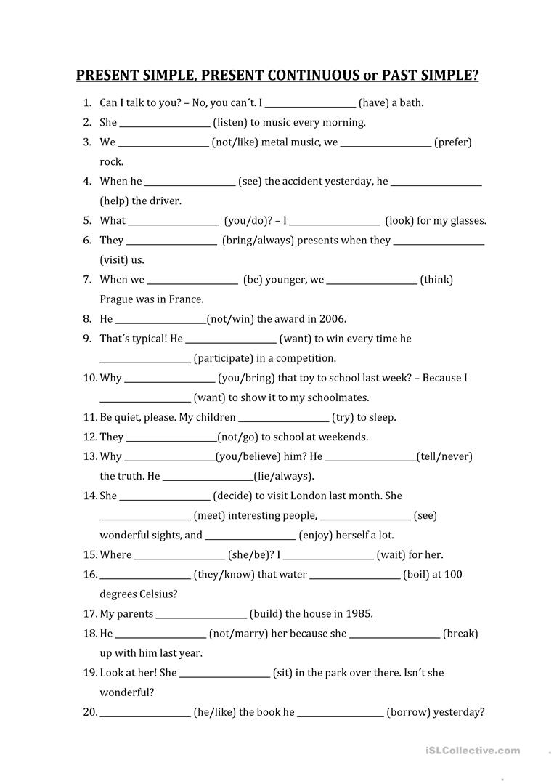](https://www.google.gr/url?sa=i&url=https%3A%2F%2Fen.islcollective.com%2Fenglish-esl-worksheets%2Fgrammar%2Fverb-tenses%2Fpresent-simple-present-continuous-past-simple%2F98887&psig=AOvVaw0E9Wqkry4PB4K8wt8Nfis5&ust=1585072792359000&source=images&cd=vfe&ved=0CAIQjRxqFwoTCIiRy7iWsegCFQAAAAAdAAAAABAr)