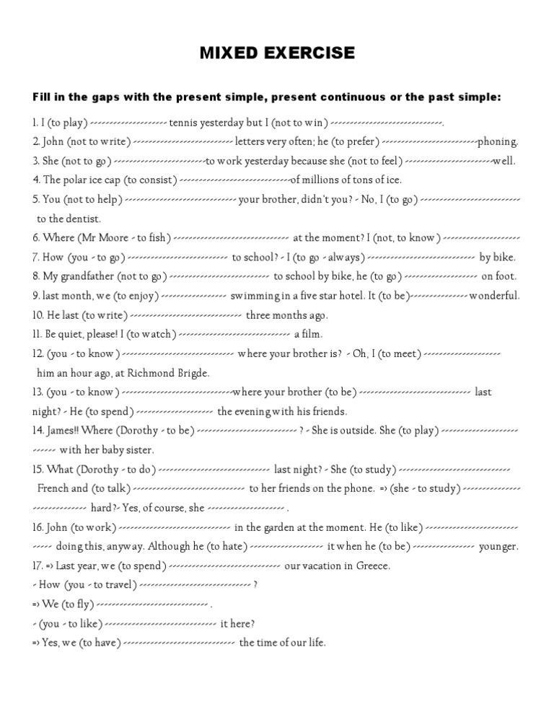

- played /did not
- does not/ prefers
- did not/ was not feeling
- consists
- helped/ went
- is Mr. Moore fishing/ I do not know
- do you go/ I always go
- does not go/ he goes
- enjoyed/ was
- wrote
- I am watching
- Do you know/ met
- Do you know/ was/ spent
- Where is Dorothy?/ is playing
- What was Dorothy doing/ was studying and talking/ Was she studying/ Of course she was (or Did she study hard?- Of course she did ).
- Is working/ likes/ hated/ was
- Spent/did you travel/ flew/ Did you like it/ had

