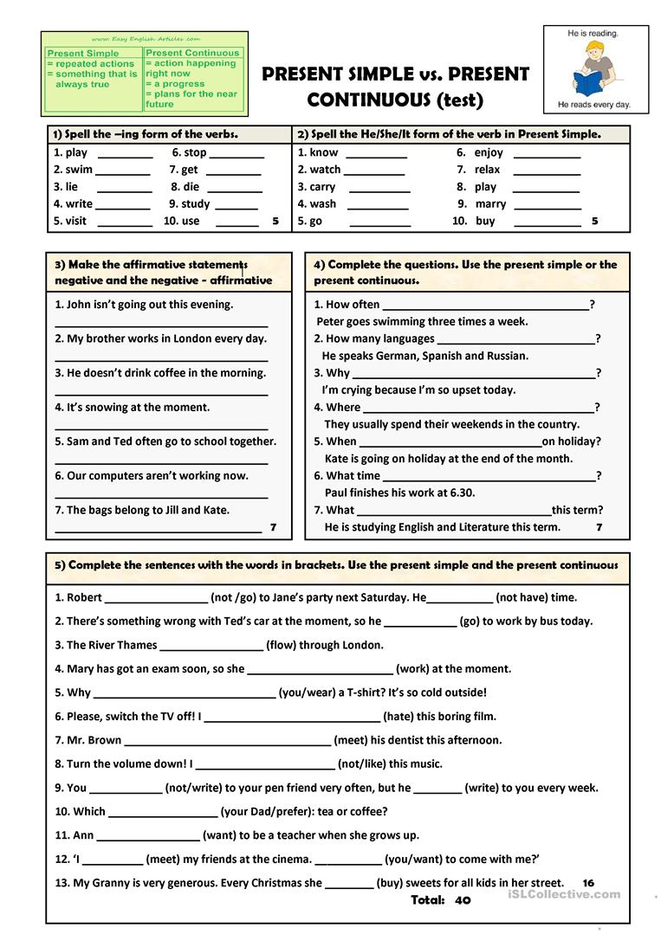

1.
- playing
- swimming
- lying
- writing
- visiting
- stopping
- getting
- dying
- studying
- using
2.
- knows
- watches
- carries
- washes
- goes
- enjoys
- relaxes
- plays
- marries
- buys
3.
- John is going out this evening.
- My brother does not work in London everyday.
- He drinks coffee in the morning.
- It’s not snowing at the moment.
- Sam and Ted do not go to school often together.
- Our computers are now working.
- The bags do not belong to Jill and Kate.
4.
- How often does Peter go swimming?
- How many languages does he speak?
- Why are you crying?
- Where do they usually send their weekends?
- When is Kate going on Holiday?
- What time does Paul finish?
- What is he studying this term?

5.
- Robert is not going to Jane’s party next weekend. He does not have time.
- There is something wrong with Ted’s car at the moment, so he isn’t going to work by bus today.
- The River Thames flows through London.
- Mary has got an exam soon, so she is not working at the moment.
- Why are you wearing a T-shirt? It’s so cold outside.
- Please. Switch the TV of! I hate this boring film.
- Mr. Brown is meeting his dentist this afternoon.
- Turn the volume down! I don’t like this music!
- You don’t write to your pen-friend very often, but he writes to you every week.
- Which does your dad prefer? Tea or coffee?
- I’m meeting my friends at the cinema. Do you want to come with me?
- My Granny is very generous. Every Christmas she buys sweets for all the kids in the street.

