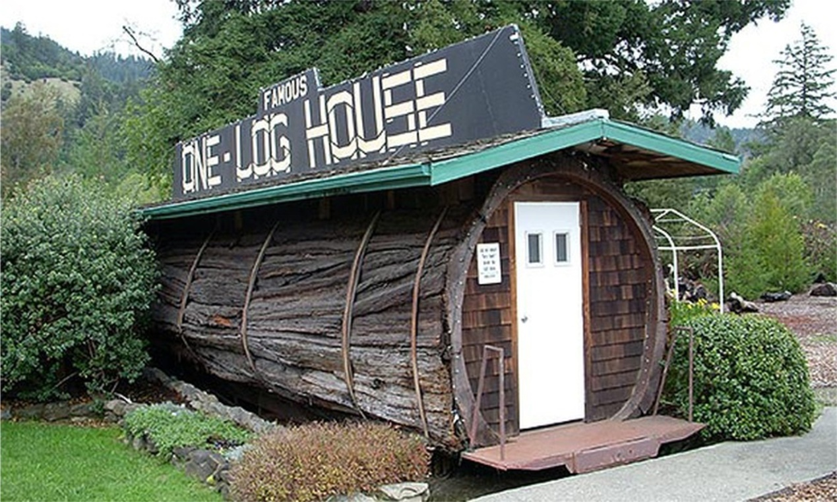
House in a tree log
It’s called “One-Log House”. It’s in California, USA. It’s height is 2,5 m and it’s 10m long. It was built in a log of a giant tree 2000 years old.
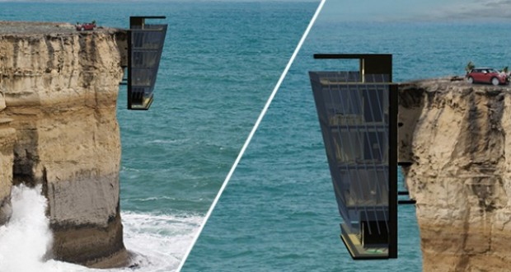
House on a crag
It’s in Australia. It’s built to be tangent to a crag like a limpet on the rocks. It’s roof is at the same level with the ground and you have to move downstairs to find the other floors of the house. The view takes your breath away.
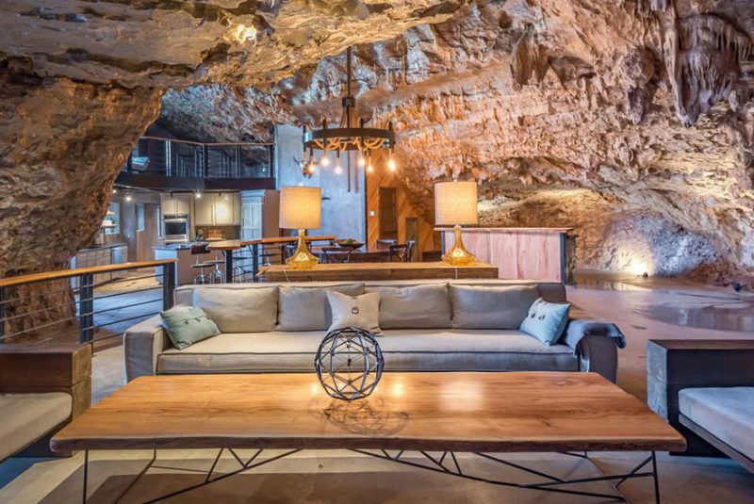
House in a cave
It’s in the suburbs of Arkansas. It’s called “Greek Cave Lodge”. At first, it was built as a shelter. However, it’s present owner developed it into a modern hotel that can receive as guests up to 8 people. It also has a helipad.

Παντελής Γκότσης
Αντώνης Γαροφάλου

