A PROJECT FROM :
ANTONIS LIARMAKOPOULOS
MEXICAN HOUSES
Mexican culture has managed to combine the European elements of the Spanish settlers and the indigenous Aztecs, Toltecs and Maya, presenting us with a colorful and cheerful bright image that dominates the decoration of the houses.
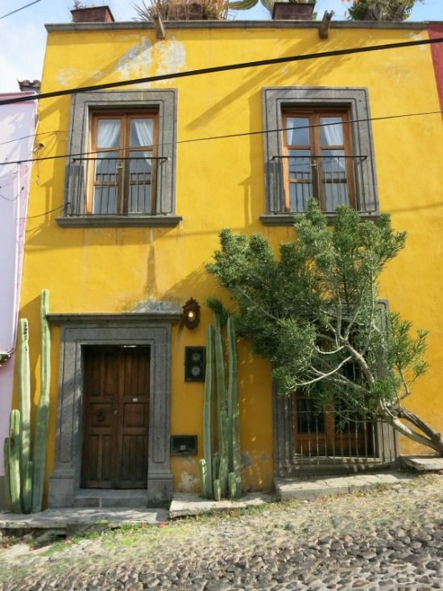
Source: Pinterest

After all, it is no coincidence that in 2010 the Mexicans emerged as the happiest people on the planet. So if you want to give a little note of optimism and fun in your space, maybe you should seriously consider following the example of Mexicans in decorating your home (a traditional Mexican decoration is usually the cacti on the windows)
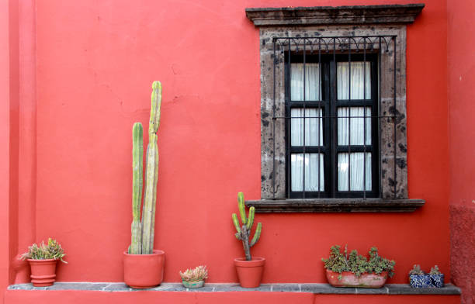

As I said, Mexican homes are dominated by bright and luminous colors, mainly earthy with shades that include warm orange and tile, plum and pink, deep blue, brown and terracotta, deep yellow and bronze. We will find these colors not only in fabrics, decorative objects, floor tiles and furniture but also in the interior and exterior walls of the house.
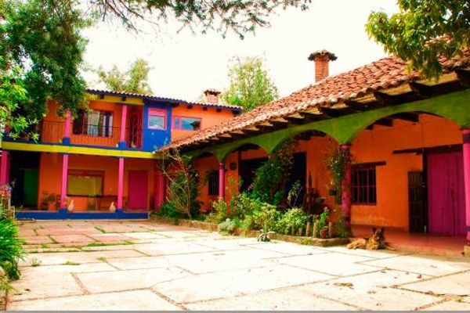

If they seem a bit too much you can just paint one wall of the house in a bright orange color and keep the other walls in more neutral tones.
Also the style of decoration with influences from distant Mexico includes mainly natural materials such as clay and wood or bronze and copper.
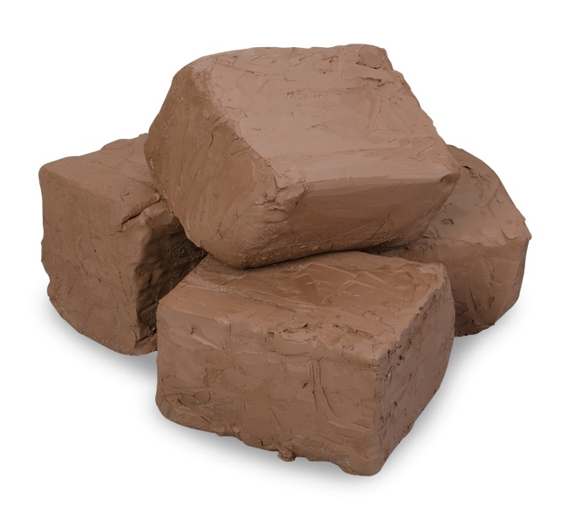
Source: Naaco Source: Scientific American Bloga
Wooden furniture mostly has carved embossed designs that will make it particularly beautiful and impressive. Their fabrics usually consist of patterns of geometric shapes such as rhombuses and horizontal lines, while even the carpets are colorful.
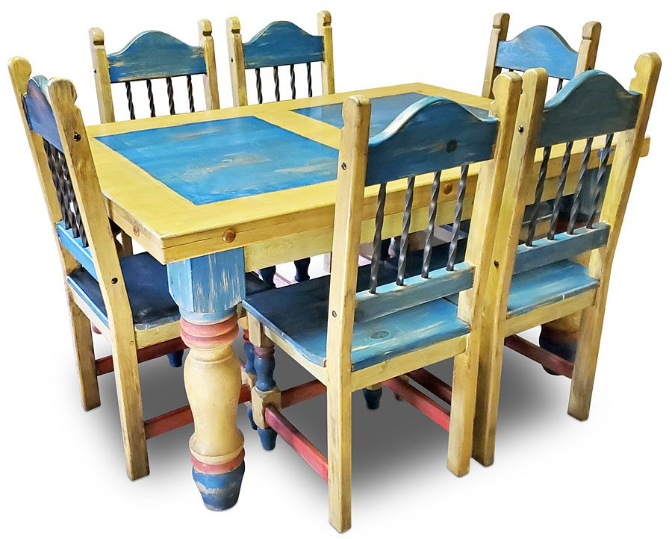
Source: Direct From Mexico
Usually houses in Mexico have courtyards or face the garden as a continuation of their home. Plants are an essential element in the selection of cacti to dominate.
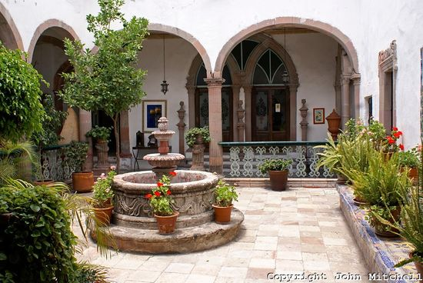
Source: Pinterest
However, the decoration reminiscent of a Mexico quite well not only with the Greek climate but also with our temperament.

SOURCES: INTERIOR DÉCOR : https://www.interiordecor.gr/
PINTEREST: https://gr.pinterest.com/search/pins/

