ARTICLE / POST 2. - BROCHURE - 30/11/2022

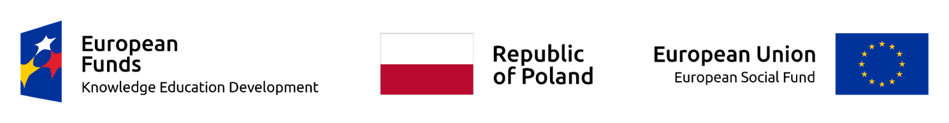

Summary of the project – final brochure of project results
We are presenting a publication summarizing the implementation of the project "Spread your wings with transnational mobility", in which our school had the opportunity to participate as a partner school.
In October 2022, a group of students from the Primary School in Ciechanowiec and their guardians stayed in Greece, where, together with Litochoro Gymnasium, they carried out a two-week program of classes based on learning and developing foreign languages and getting acquainted with the geography, culture and customs of another European Union country.
The two-week program was implemented as part of the key competence development project "Spread your wings as part of transnational mobility". The subject matter of the project was varied, but most of the classes focused on learning foreign languages and science, as well as integrating young people with their peers from Greece. In addition to language and cultural activities, the participants also took part in computer science, nature and geography, history, art, music and technical classes.
The project was part of the implementation of the school core curriculum by developing learning outcomes in a non-formal form. Its main goal was to raise the level of key competences of primary school students. Nicolaus Copernicus in Ciechanowiec, by carrying out foreign mobilities. 20 students and 4 tutors were involved in their framework, acting as accompanying persons (care for students, mentoring, monitoring of the implemented program and conditions).
Project entitled "Spread your wings with transnational mobility" No. 2021-1-PMU-4389, implemented from the European Social Fund under the Operational Program Knowledge Education Development, project "Transnational mobility of students".

