1  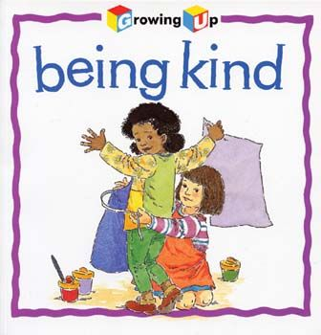  Be kind to your brother, sister, parents. | 2    Sing a song in English. | 3  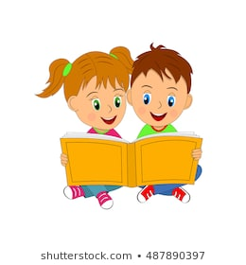  Read a book in English with your classmate for 15 minutes.
4    Talk about a Christmas tradition in your family. | 5    Write a Christmas riddle in English. | 6    Make a Christmas card and give it to a classmate or a teacher.
7    Hug your family members and use positive words when talking. | 8    Visit an older family member and have tea & chat with them. Be an attentive    listener. | 9    How many Christmas foods can you think of? Make a Christmas menu.
  10  Write a Thank you note in English to a classmate who's helped you lately. | 11  Role play Christmas  morning in a group of five. | 12    Play Hangman with Christmas words in class.
13    Make a quiz about Christmas in groups of five. Exchange quizzes. | 14    Play Santa says in class (like Simon says, maybe with Christmas activities,  too). | 15  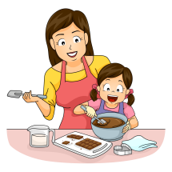  Help your mum with lunch or make lunch yourself.
16    Post notes of kindness around your home for your  family to see. | 17    Write down 5 things you are thankful for this year. Share them with your class. | 18    Stand in a circle. Pay a compliment to the  classmate on your left.
  19  Play the Telephone game whispering to the next classmate's ear (Christmas themed sentences. | 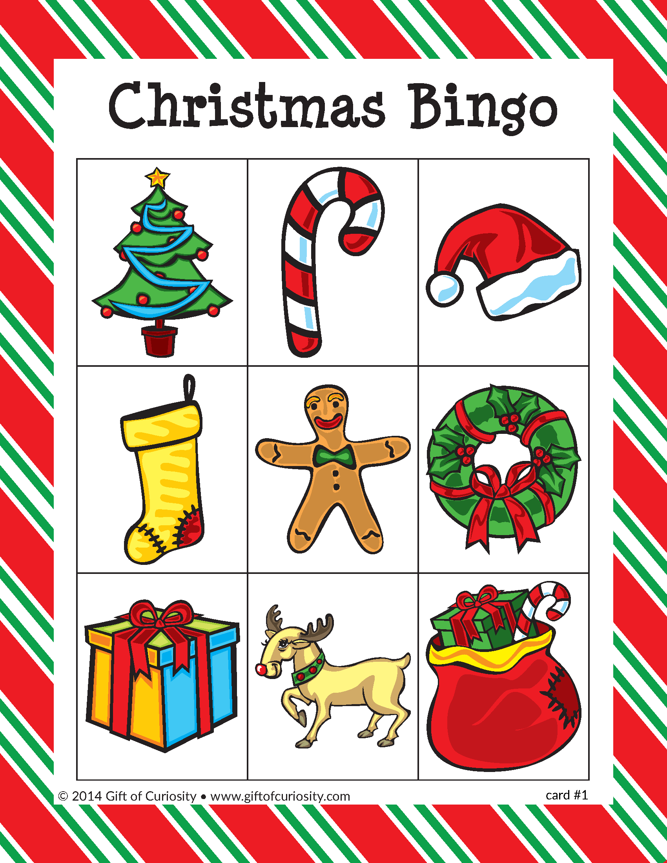  20  Play Christmas bingo. | 21    Stand in a circle. Tell the classmate on your right  why you like them.
  22  Make Christmas cards for your neighbours and write something nice in them before posting them. |   23  Prepare all the decorations so you can enjoy putting them up tomorrow. Remember the nice occasions they witnessed. |   24  Watch a Christmas cartoon/film and have a Christmas discussion afterwards.

