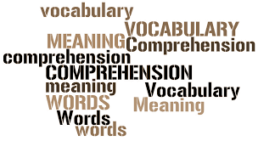
Complete using abuse or misuse
1 She __________the car so much that it needed a new gearbox.
2 There was no need to ___________your mother like that.
3 He _______________ his authority by using his company’s car for personal reasons.
4 Their stereo is out of order because they were continually ____________the buttons.
Complete using knuckle-eye-nose-finger-head-foot
1 The ship____________its way slowly out of the harbor.
2 With an attitude like that you are __________for trouble.
3 She ____________the silk fabric.
4 Who will ___________ the bill for dinner?
5 It’s time you ____________down to some hard work.
6 The policeman ____________up the young man suspiciously.
Complete the following sentences using words
chain-spin-blow-ill-cross
1 The defendant was __________-examined
2 Don’t _________-dry wool pullovers.
3 Do you _________-dry your hair?
4 He should cut down; he ________ -smokes.
5 You shouldn’t __________-treat that animal.
Explain the following expressions :
1 speaking in riddles…………………………………………………………………………………………………………..
2 to add a pinch of salt to something…………………………………………………………………………………
3 ripped off………………………………………………………………………………………………………………………..
4 off your rocker…………………………………………………………………………………………………………………
5 the cold shoulder…………………………………………………………………………………………………………………..
6 he’s on the straight and narrow……………………………………………………………………………………
7 root out……………………………………………………………………………………………………………………………
8 refrain from………………………………………………………………………………………………………………………
9 fend for oneself…………………………………………………………………………………………………………………..
10 scott-free…………………………………………………………………………………………………………………………….

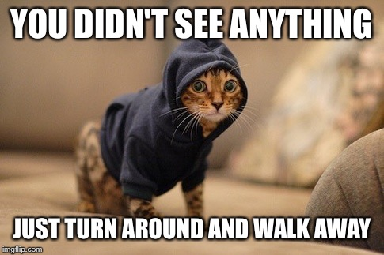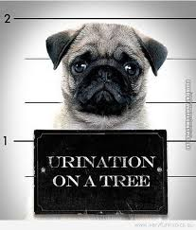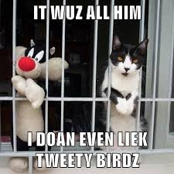https://media.giphy.com/media/26UyJlmLGEeGs/giphy.gif
There are many crimes and offences like : blackmail,kidnapping,arson,trespassing,manslaughter,smuggling,forgery,bigamy,baby or wife battering, conspiracy, fraud, drug peddling, spying ,treason, hijacking, obscenity, bribery, corruption and petty theft.
Which of the above could involve the following?
Counterfeit money, pornography, hostages, a ransom, heroin, a traitor, state secrets, contraband.

